SLPYHA Board Meeting Agenda
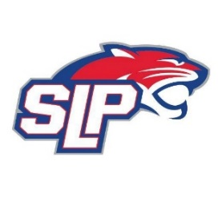
Date: 6/7/21
Roadside
7:00pm

Attendees: Scott Lichter, Michelle Rice, Mike Mliner, Corey Piekarski, Jason Shipman, Adam Kiedrowski, Kevin Mitties, Mike Fitzpatrick, Jeremy Flaten, Bob Roloff
Guests: Connor Gagnon, Chris Lueck and Tim Manz

- President Report: Scott Lichter
- Call to order: 7:07pm
- Approve agenda
- Approve minutes from 5/10/2021 meeting, motion: Lichter, move: Mitties
- Latest D10 updates
- High School Coaches (7pm)
- Tim Manz, scheduling (8pm)
- Scheduling tournaments
- Golf tournament
- Vice President Report: Michelle Rice/John Pitzl
  - SLP tournament
- Treasurer Report/Gambling Report: Mike Mliner
  - May gambling report and updated gambling funds usage budget
- Secretary Report: Corey Piekarski
- Traveling Director Report: Jason Shipman/Adam Kiedrowski
- Girls Traveling Director Report: Kevin Mitties
  - Girls co-op update
- Mite Director Report: Mike Fitzpatrick
  - Cubs program (start date and number of sessions)
- Coaching Director Report: Jeremy Flaten/Bob Roloff
- New/ongoing Business:
- Motion to dismiss: 9:45pm, motion: Lichter, move: Piekarski

