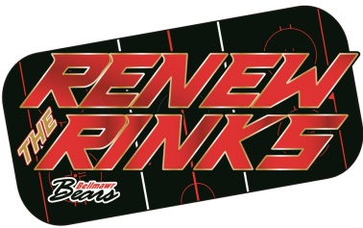
2019-2020 Season
Dear Local Business Member,

Bellmawr Hockey Association Inc. is a non-profit volunteer organization which has served the Bellmawr Borough community since 1988. We offer players and families the opportunity to be a part of an organized sport which promotes sportsmanship for the youth of Bellmawr and surrounding areas. The league serves youth ages 4-15. Our organization offers fall and winter hockey sessions as well as a spring tournament season.

The 2019-2020 season is fast approaching and we are continuing our “Renew the Rinks” campaign. Through the support of the Bellmawr Borough, local businesses, organizations, and community members we plan to make this season a memorable one for all involved.

There are a variety of options for you to help the Bellmawr Hockey League AND promote your business. Please see the attached form and decide to join us for this year’s campaign. Once the check is received a W9 will be mailed out to your business. Check should be made payable to Bellmawr Hockey. Please mail your check and the attached contact to Johann Fina at 213 Third Avenue Bellmawr NJ 08031. We asked that if you would like your company logo on the sign that you email a vector file to the below email address. If a vector file is not received your company name, address, phone number and website will be on the sign. We thank you for your time and consideration. If you would like to learn more about our organization, please visit www.bellmawrhockey.com

We look forward to this season and are excited about the opportunities for the community and our players! If you have any questions, please do not hesitate to email Bellmawrstreethockey@gmail.com or call 609-319-1802.

Bellmawr Hockey Association Inc.
Fundraising Committee

