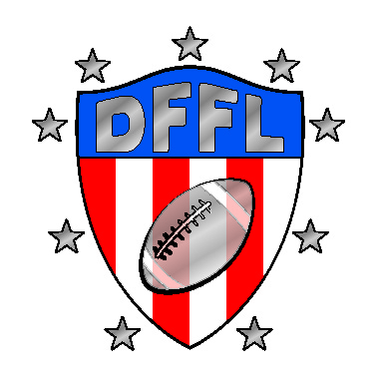
COACHES CODE OF CONDUCT

The Dothan Flag Football League (DFFL) has established the following “Coaches
Code of Conduct” for coaches in all of our youth sports programs. All coaches are expected to know, promote, and adhere to the following standards of conduct:

• Remember that these programs are for the kids; they are not for coaches or parents! Therefore, all kids deserve a right to fairness at all times.
•Coaches must conduct themselves in a manner that would be an example and a role model to the youth under their direction.
• Promote good sportsmanship, team work, physical conditioning and teaching skills appropriate to the sport. DO NOT TEACH OR ALLOW ROUGH OR DIRTY TACTICS OF PLAY.
• Adhere strictly to the rules of the game and not attempt to change or manipulate those rules in order to win or for personal benefit.
•No smoking, drinking, or being under the influence of alcohol or drugs will be allowed in the dugouts, on the playing field, or at any time while coaching.
•Model grace, dignity and composure regardless of the outcome of the game.
• Abuse or harassment of players, umpires, scorekeepers, employees, or spectators in any form will not be tolerated.
• Profanity of any kind will not be tolerated. Degrading or demoralizing of players is not acceptable.
•Coaches agree to support and work with assigned team throughout the designated season, and agree to hold regular practices (at least one per week) and show up to scheduled games.
• All coaches must adhere to each sport’s Mandatory Play Rule (MPR). Failure to comply with this rule could affect your coaching status.

APPLICATION TO BE A RECREATION DEPARTMENT VOLUNTEER
(Print First& Last Name) _________________________ hereby applies to be a volunteer in the Dothan Flag Football League. In so applying, I acknowledge that a criminal background history will be obtained. (Fill out and sign authorization to obtain criminal history.)
I further acknowledge the Dothan Flag Football League has created a Coach’s Code of Conduct. I have read that code which is described above and agree to abide by these standards. I understand that if I do not abide by the Coach’s Code of Conduct, I will be removed as a volunteer, and may be prohibited from volunteering in future years. I release, indemnify and agree to hold harmless, the DFFL and its agents, elected officials, servants, and employees from all claims, action, causes of action and rights of recovery or reimbursements of any type that any participant has or may have in the future which arise from or are related in any manner to the activity(ies) (including, but not limited to, claims of bodily injury and property damage or loss), and I assume all risks and hazards incident to such activity(ies) and transportation to and from the same. This instrument is signed both individually and on behalf of the participant(s) present at activity(ies).

Dated this ______day of _________, ______

________________________________
Applicant’s Signature

