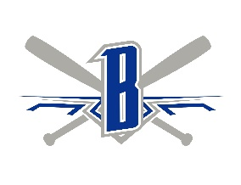

BRAINERD BAXTER BASEBALL ASSOCIATION, INC.
Returning Coach Application

Name: Contact Phone Number:
Address:
Email address:
Age group coached last season (check one):
⌂ 9U ⌂ 10u ⌂ 11U ⌂ 12U ⌂ 13U ⌂ 14 U
⌂ Head Coach ⌂ Assistant Coach ⌂ Either
Position (re)applying for the upcoming season:(check one):
⌂ 9U ⌂ 10u ⌂ 11U ⌂ 12U ⌂ 13U ⌂ 14 U
⌂ Head Coach ⌂ Assistant Coach ⌂ Either

Please answer questions / provide info as requested below:
- Please provide a summary of the previous season:
- Successes / Challenges

- Goals for next season

Last Season Head Coach Only
- How many double headers / “regular season games” do you play last season?
- How many tournaments (including state, regional and WS) did you participate in last season?
- How many total games did you play last season?
- Did you feel like this was too many / too few or just about right?

If selected as head coach again for next season, how many tournaments do you plan to enter (above and beyond our home tournament).

- What are some of the things that you feel you did well as a coach / things you need to work to improve?

- Do you have any concerns that you’d like the board to be aware of regarding the previous or upcoming season?

- You will be asked to participate / provide assistance in our Winter Skills and other player development activities throughout the year as part of being selected as an assistant or head coach. Is this something we can count on you to do?

- Any other information you would like to share?

***Brainerd Baxter Baseball Association requires background checks on all coaches; your application for coaching is your acknowledgement of this. By filling out this application, you agree to follow all rules and policies outlined per the Brainerd Baxter Baseball Association. ***

Applicant Signature Date: / /
Printed Name

Please email completed application to BBBA Board of Directors:
brainerdbaxterbaseball@gmail.com

*Thank you for your commitment to Brainerd Baxter Baseball Association*



