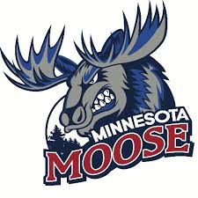
Broadcasting Intern

The Minnesota Moose Hockey Club, located in Blaine, Minnesota, is seeking an enthusiastic and motivated Broadcasting Intern to join our team for the 2025-2026 season. This internship will provide valuable, hands-on experience in the sports broadcasting field, particularly focusing on hockey. The intern will have the opportunity to assist with live game coverage, production of broadcasts, and content creation related to the team. This is an exciting opportunity for students interested in sports media, communications, and broadcasting.
Key Responsibilities:
- Help with live play-by-play and color commentary during home game broadcasts.
- Assist in the setup and breakdown of broadcast equipment (cameras, microphones, etc.) for home games and practices.
- Work closely with the team’s operations and media staff to ensure smooth integration between live broadcasts and in-game activities.
- Assist in gathering research, statistics, and relevant information for game commentary, player profiles, and game recaps.
- Contribute to the production of promotional materials for upcoming games, including broadcast promos, radio spots, and digital ads.
Required Qualifications:
- Interest in pursuing a career in sports media, communications, or broadcasting.
- Familiarity with broadcast equipment and production software (preferred but not required).
- Strong verbal and written communication skills, with the ability to engage and entertain an audience.
- Ability to work independently and collaboratively in a fast-paced environment.
- Availability to work evenings, weekends, and some holidays (game days).
Compensation and Benefits:
- This is an unpaid internship offering valuable hands-on experience in the sports broadcasting industry.
- Valuable hands-on experience working with a Junior hockey team.
- Networking opportunities in the sports and entertainment industry.
- Team merchandise and tickets to games.
How to Apply:
To apply, please send your resume and a brief cover letter explaining your interest in the Broadcasting Internship with the Minnesota Moose to mnmoosecoach@gmail.com.

