Method 1 - Website
Go To www.njsbl.us Make sure you are logged in as yourself using your valid email address
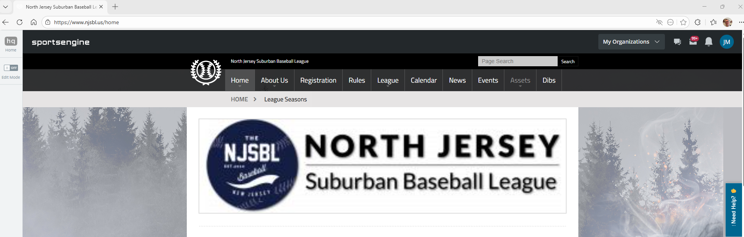

Click On My Organization Drop Down and Select the Team you want to view or Click View All Teams–
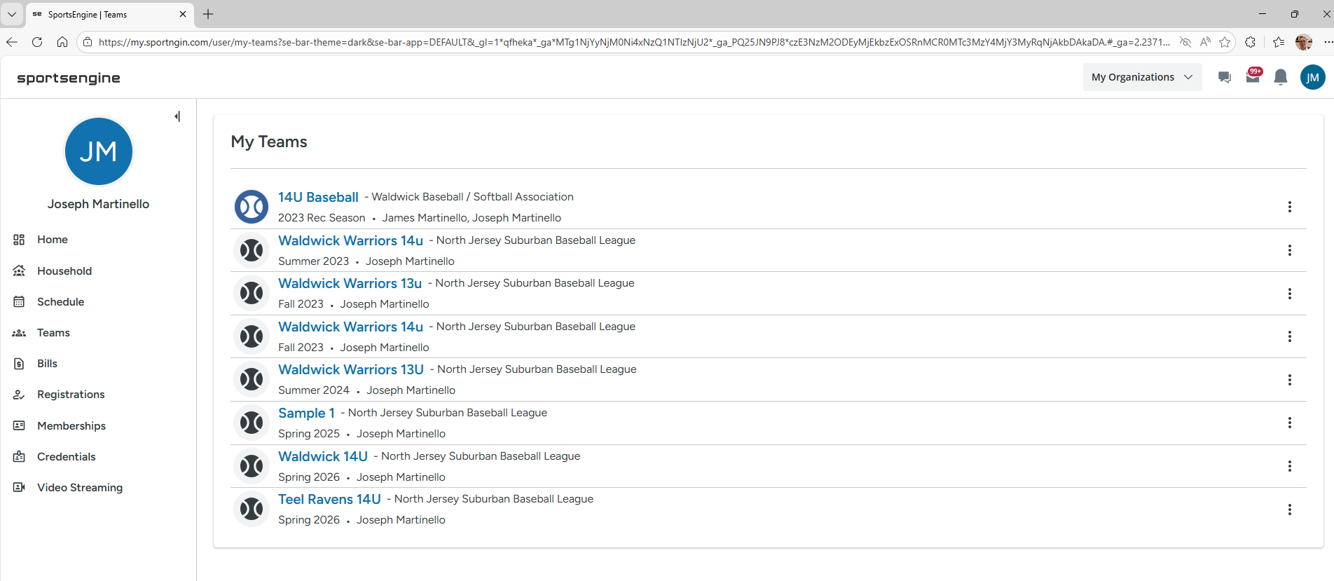
Then Click the Team Name of the Team you want to view.
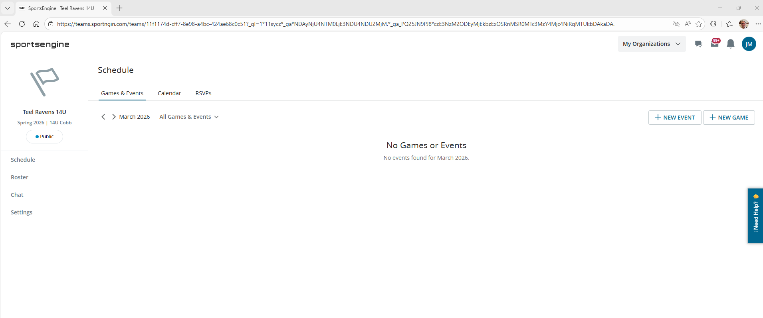

Click the Roster Label to the left
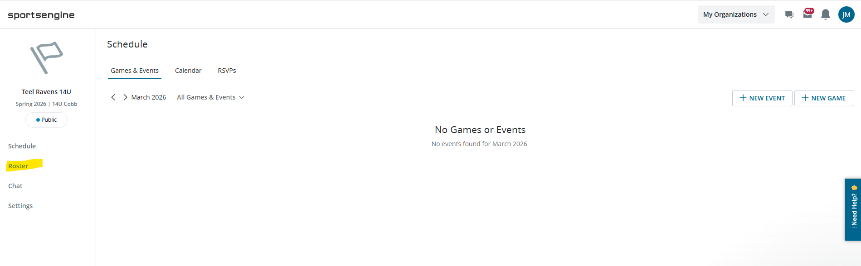
Click Add Players
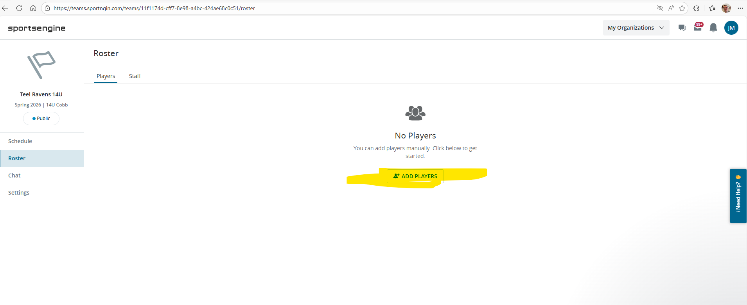
Type in First Name, Last Name –
In the First Name field Type the Name and Player Birthday as follows:
Joseph01/01/2013
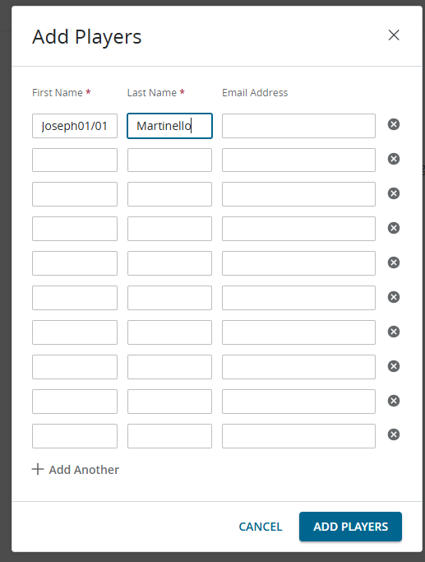
Continue Filling until all players are added then click add Players
Then Click Edit Roster and Edit Player Information
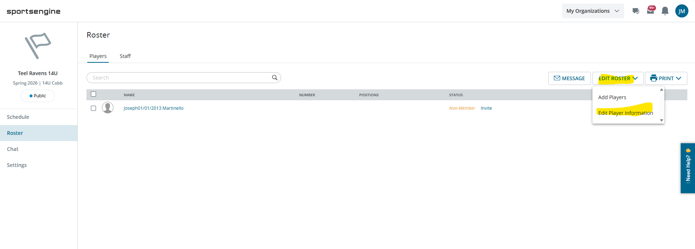
Now you can add Player Numbers and optionally positions
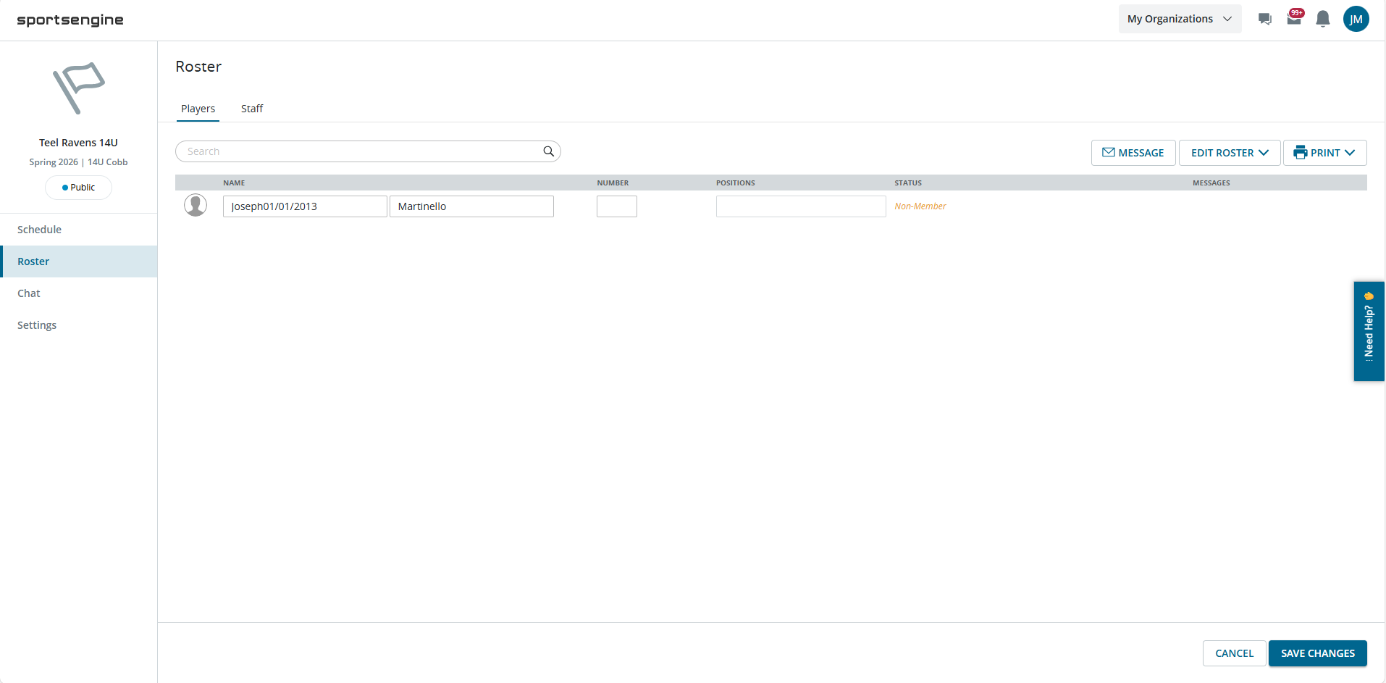
Add all player numbers and click save changes at the bottom.

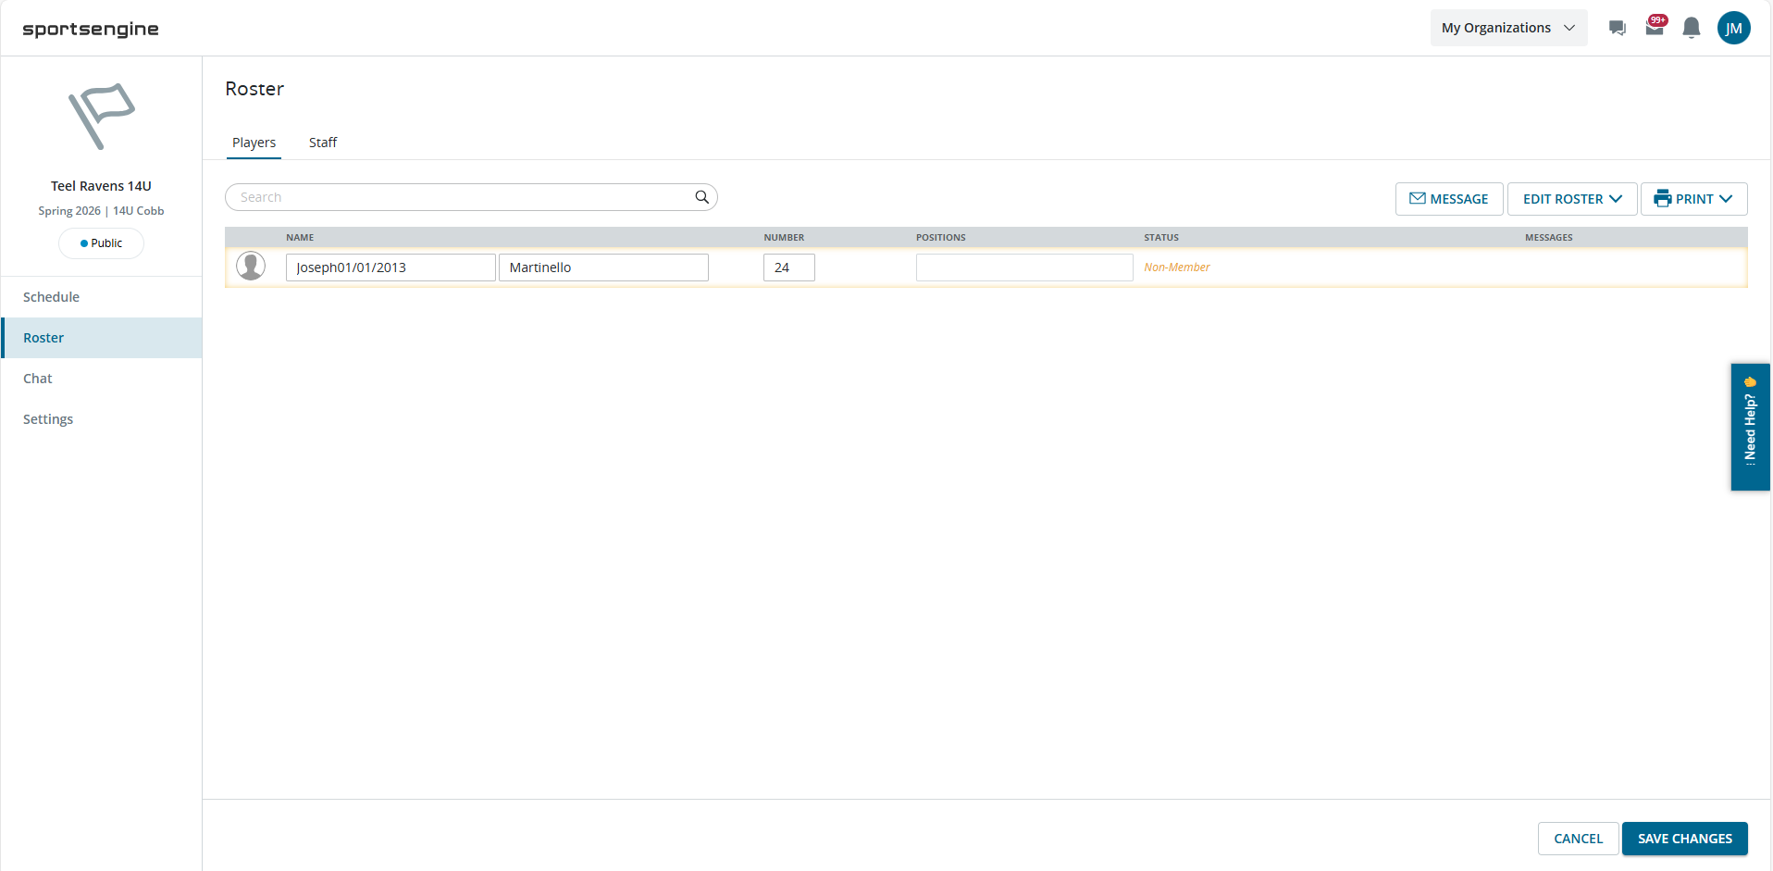

Method 2 – Sportsengine App
Login to your Team on the Sportsengine app. Then Open the Roster Tile
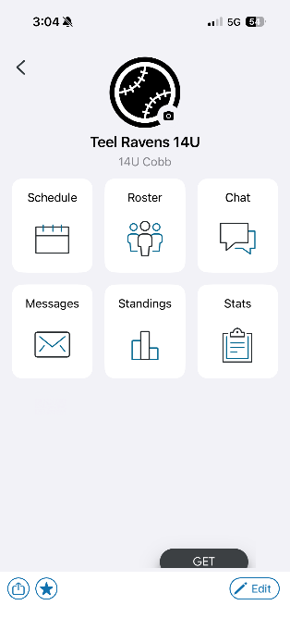
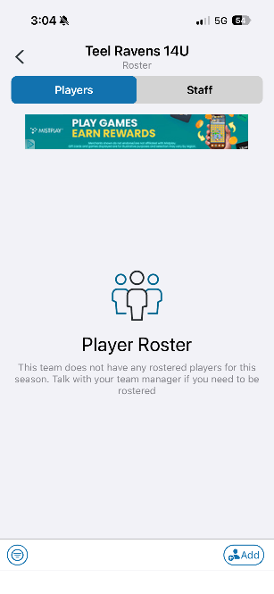

Click Add and then Player
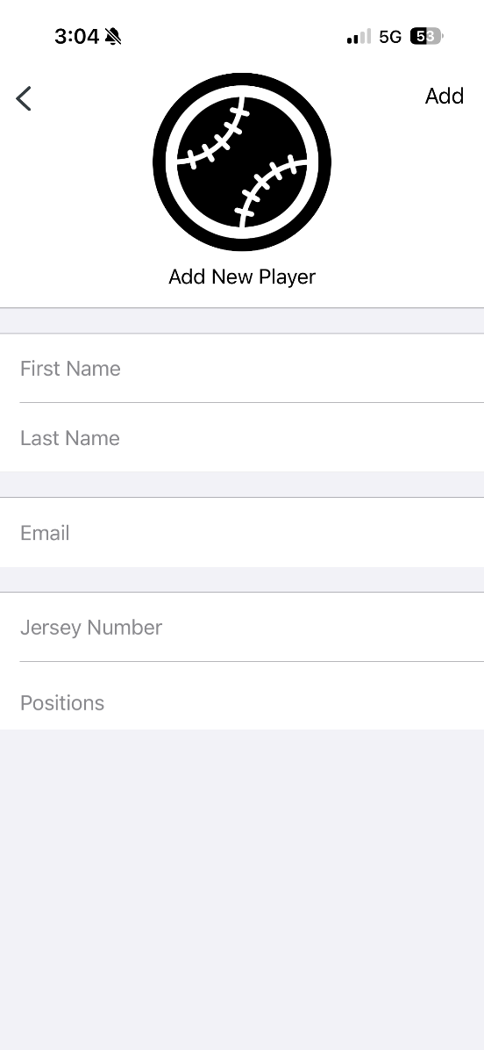
Type in First Name, Last Name –
In the First Name field Type the Name and Player Birthday as follows:
Joseph01/01/2013
This view also requires an email address to be entered.
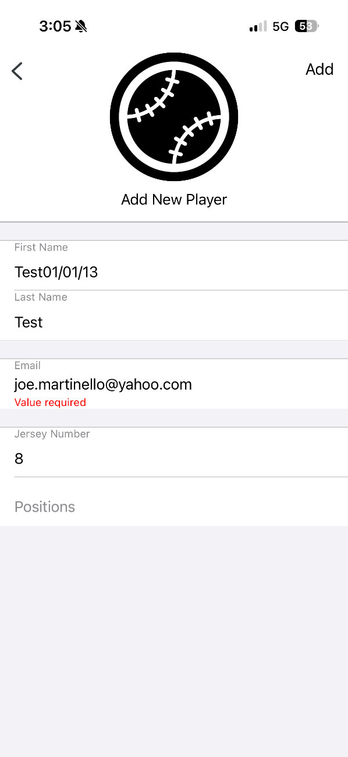
Then Click Add –

This enables teams to View Rosters and Birtdates from the Microsite
https://season-microsites.ui.sportsengine.com/seasons/692c542f39f10c9f5ada85af
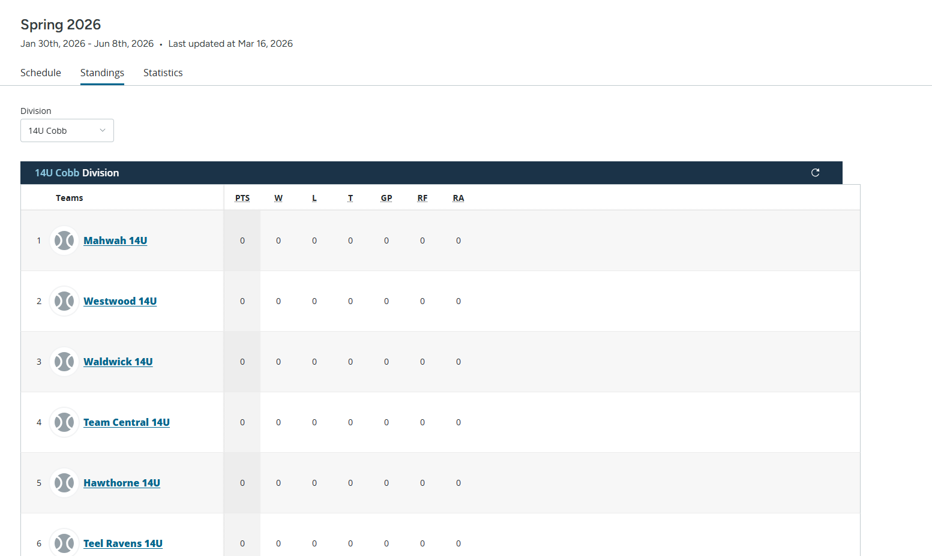
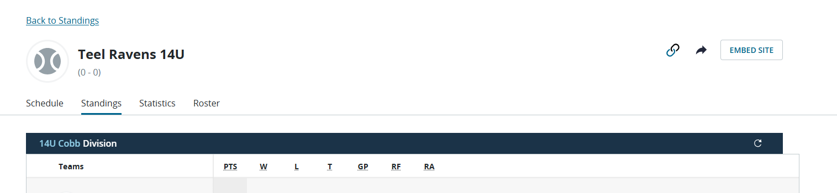
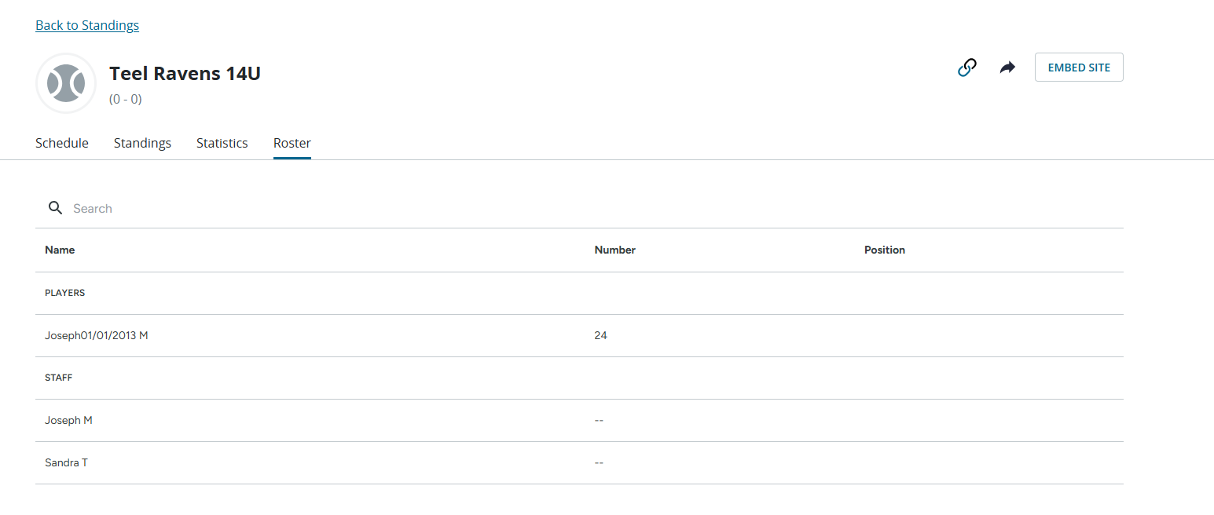

You can also see it on the Website View
Spring 2026
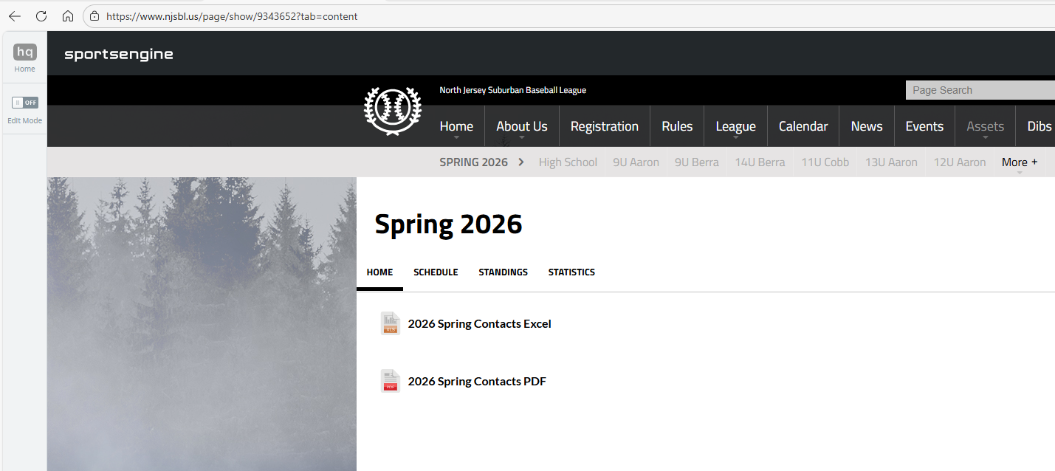
Then Follow the Arrows to get to the Division and Team.
