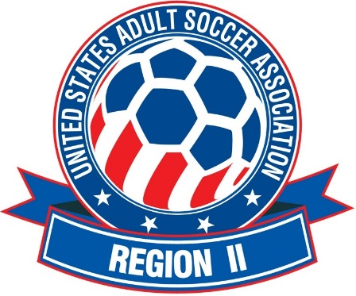

TEAM CHECK-IN INSTRUCTIONS

TEAM CHECK-IN will take place at the Complex, the initial check will begin 1 HOUR PRIOR TO THE FIRST SCHEDULED GAME. Any Changes in the initial game schedule and/or other important information, will be distributed at that time. Additionally, beyond the initial check in, a team representative should check in at the tournament desk, one hour prior to each game.
The Team Representative should have the following:
- Valid approved CURRENT YEAR player passes for all players that appear on the Official Roster, which has been issued by:
  - State Association
  - USASA League
  - Affiliated league of a State Association.

- One (1) copy of the TOC Player Pool Roster Form (Signed by a home State Association Official) Download from:
https://www.usasaregion2.com/page/show/3538387-tournament-of-champions

- Five (5) copies of the TOC Individual Game Roster Form. Download from: https://www.usasaregion2.com/page/show/3538387-tournament-of-champions
The game Rosters will be signed by an authorized TOC Official. One will be retained at the TOC Headquarters, the other 4 will be returned to the team to be used as Game Rosters (one for each scheduled game)

- If a Professional Player Release is required for any player, Then the Coach/Team Manager should have that document available for view at the TOC Check-in. A Valid Player Pass, with the signature of the Home State Association Registrar or designate reflecting that the forms have been reviewed and accepted by that home state will be acceptable.

Distributed at the end of the Team Check-in Process:
- Team Packets
- Food Vouchers (if applicable)
- Useful information regarding the facility, parking, scheduling, ect.

