GameSheet Roster Import/Viewing

1) Create an account on https://gamesheetinc.com/
2) Use your code provided in a previous email to register.
3) Login
4) Click “USAH – Minnesota District” link
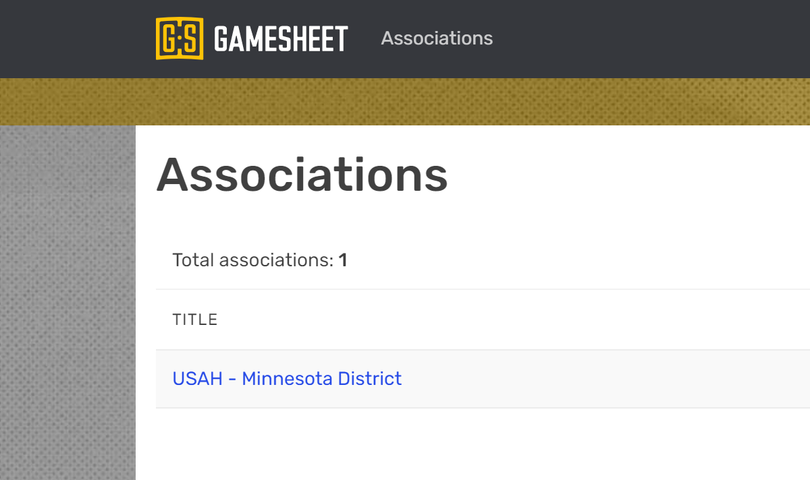
5) Click “District 10” link
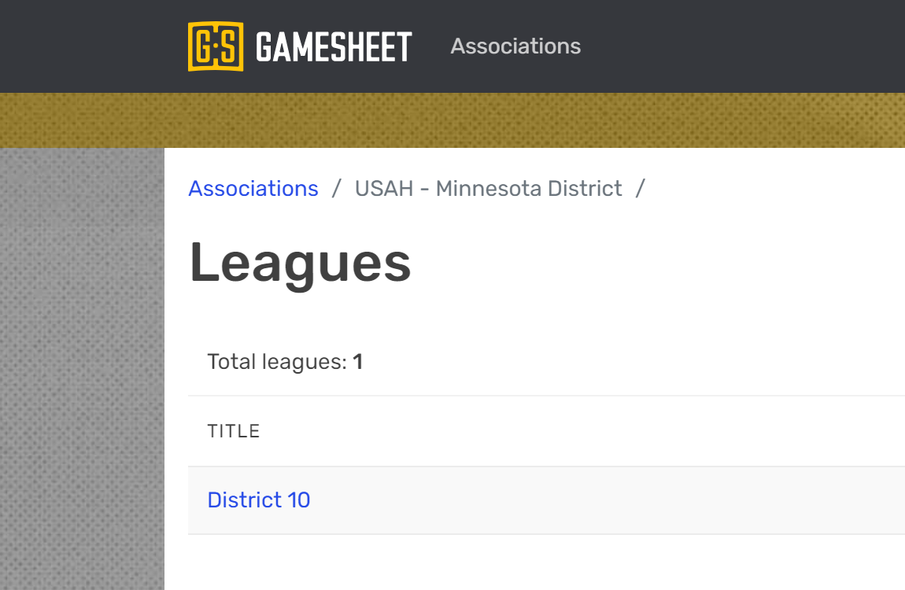

6) Click “Minnesota District 10 – 2021-2022” link
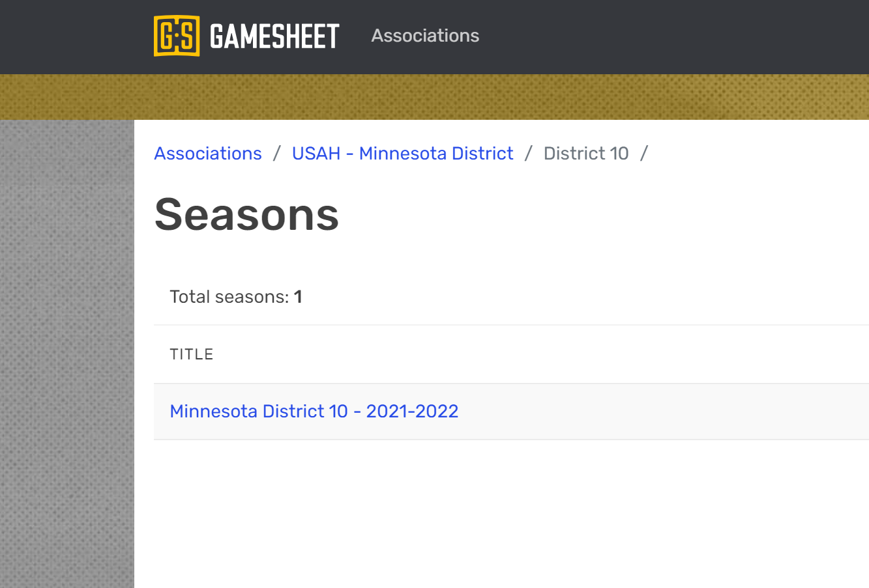

7) Click “VIEW DIVISIONS” link
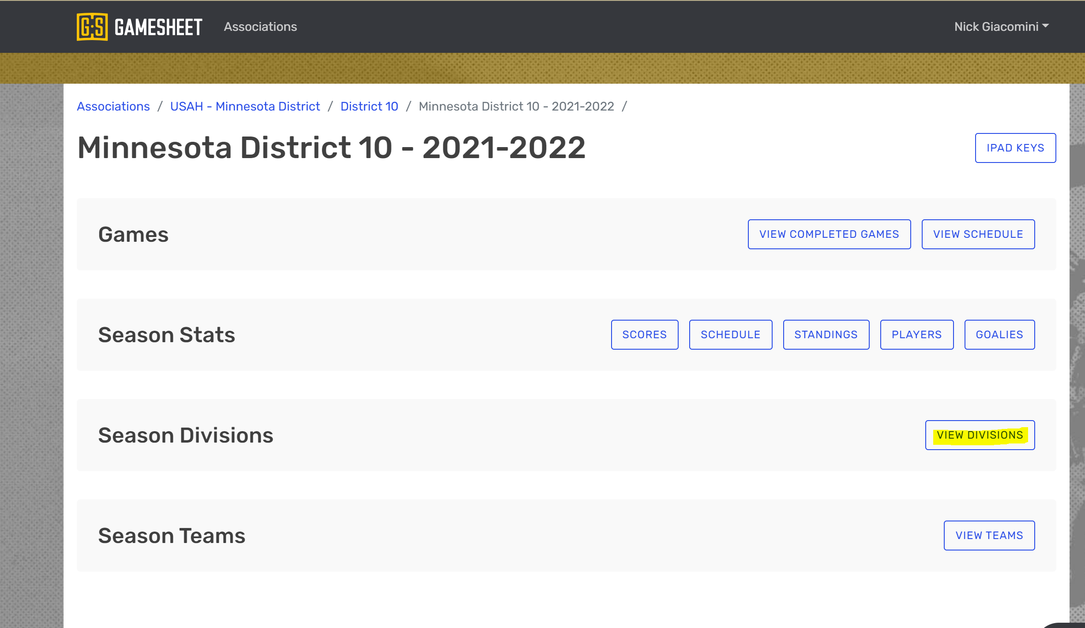

8) Click on your team’s division link:
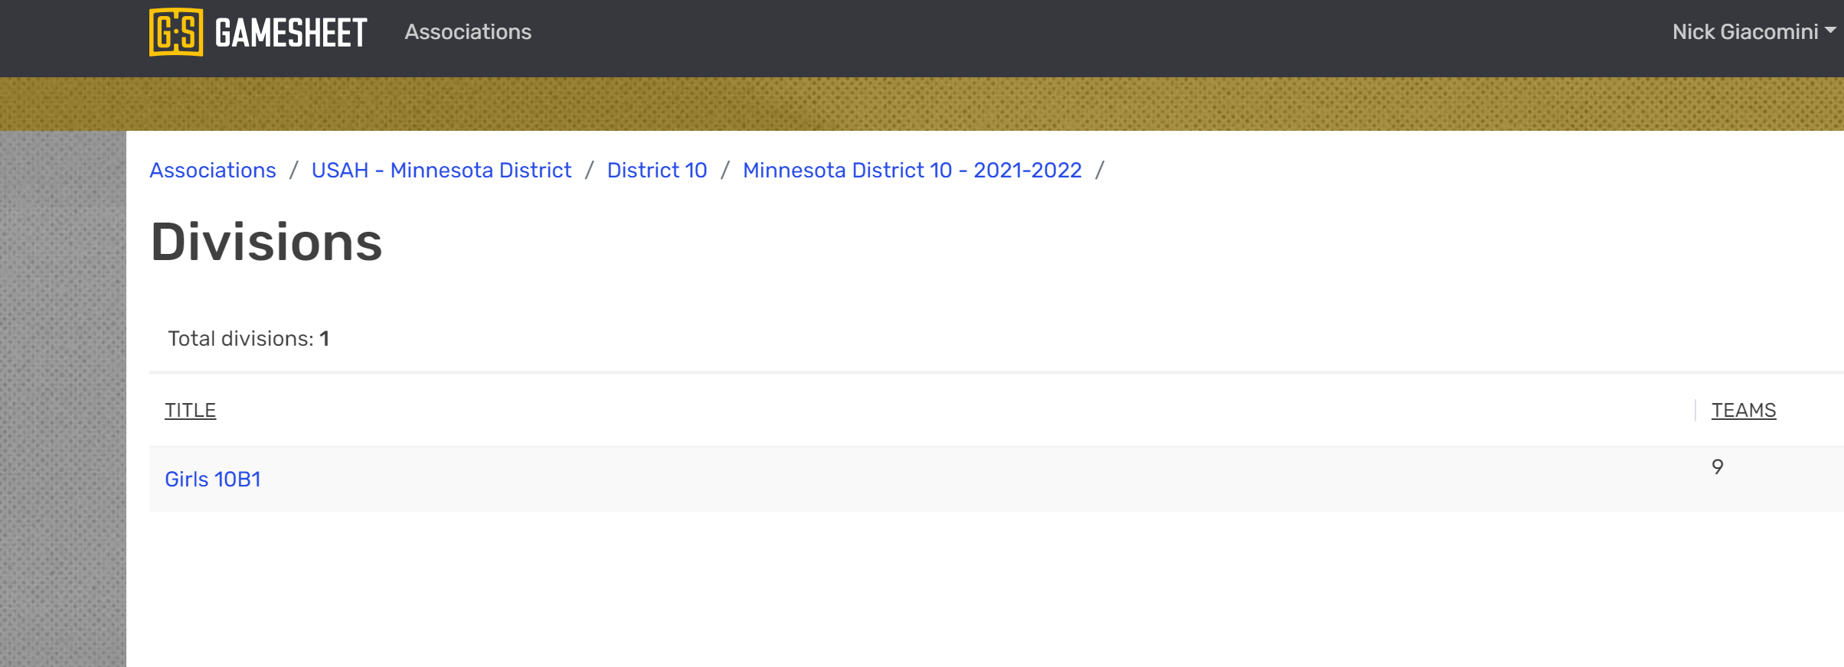
9) If your player & coaches count is 0, click on your teams name:
*Note if you have a count already present, do not proceed to Import. You can click on your team name to view the roster.
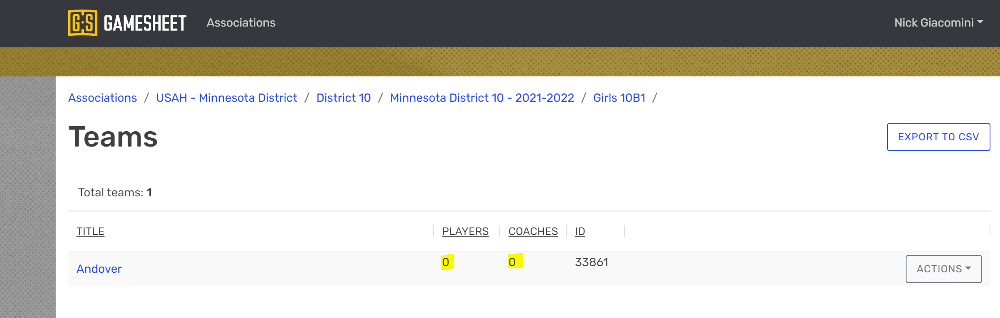

Importing a Roster
1) Click the “USA HOCKEY” import button:
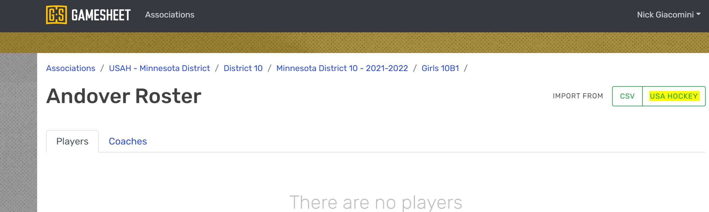

2) Enter your USA Hockey Team ID from your roster:
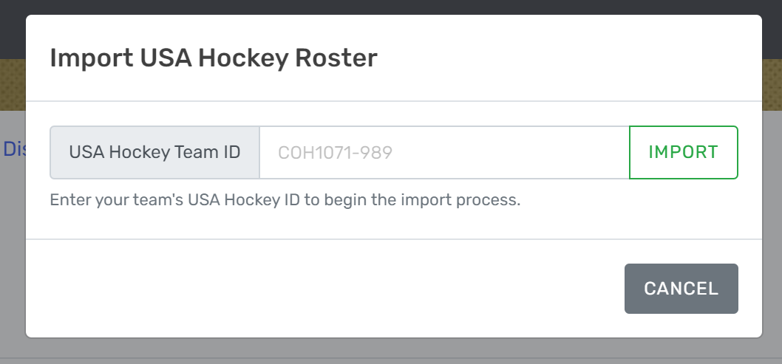

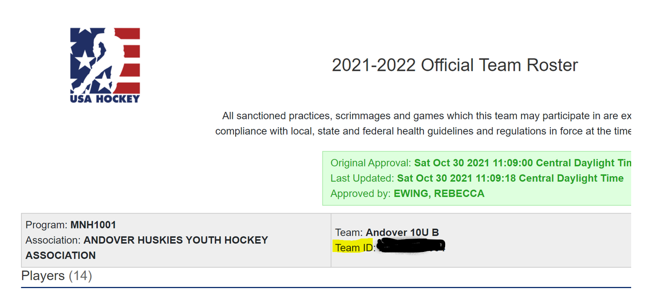

12) Click the Import button, there will be a light green progress bar, followed by a dark green progress bar:
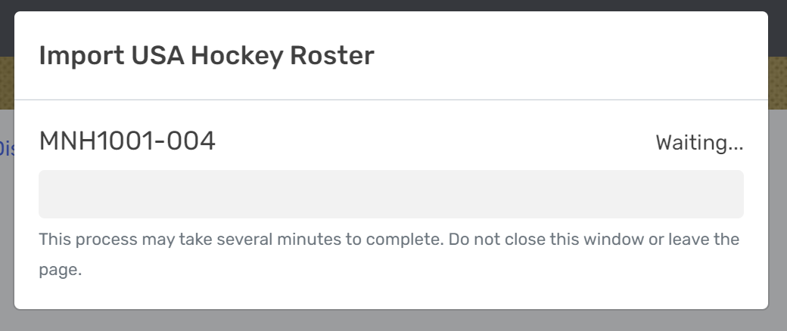

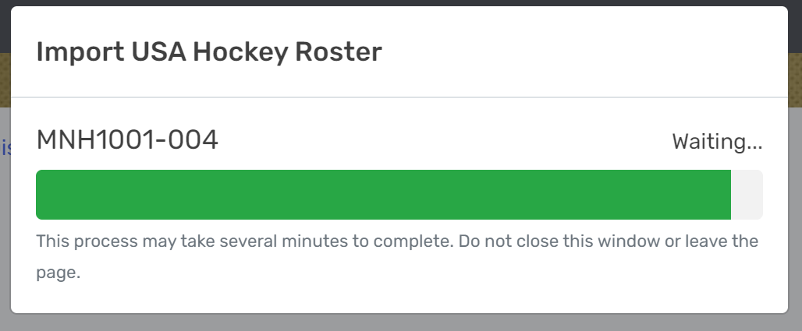

Once the 2nd dark green bar appears to be almost finished and hangs there, click the back button on your browser:
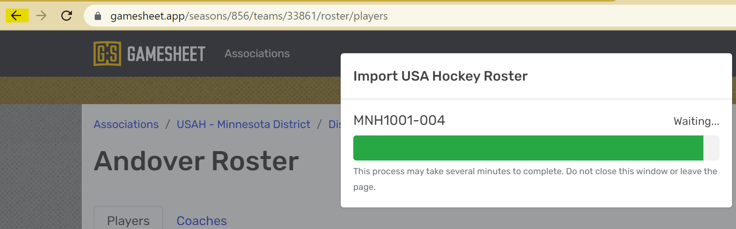
Check the player and coach count:
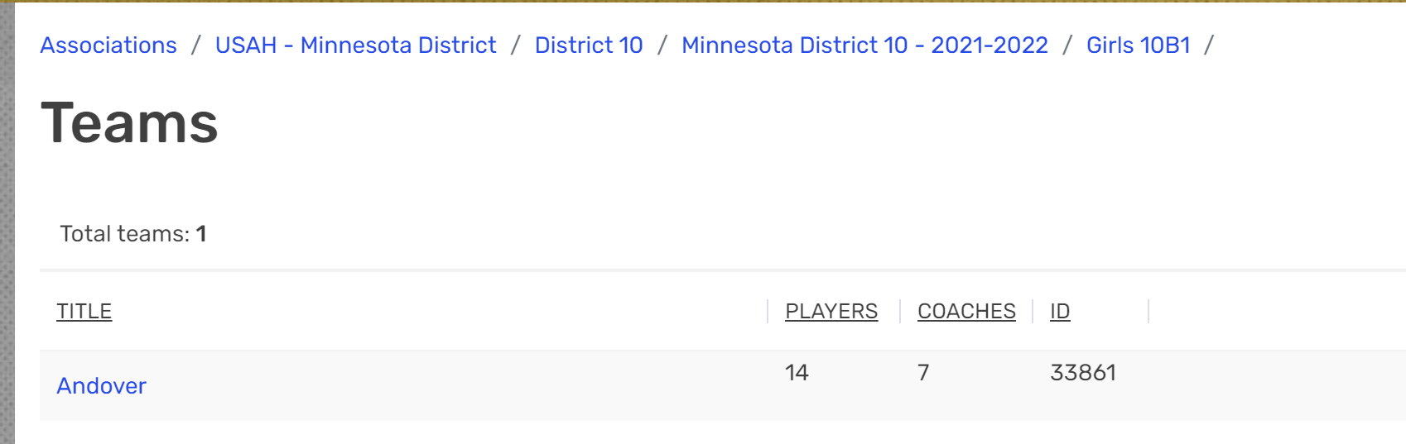

Click your team’s name to view the roster:
