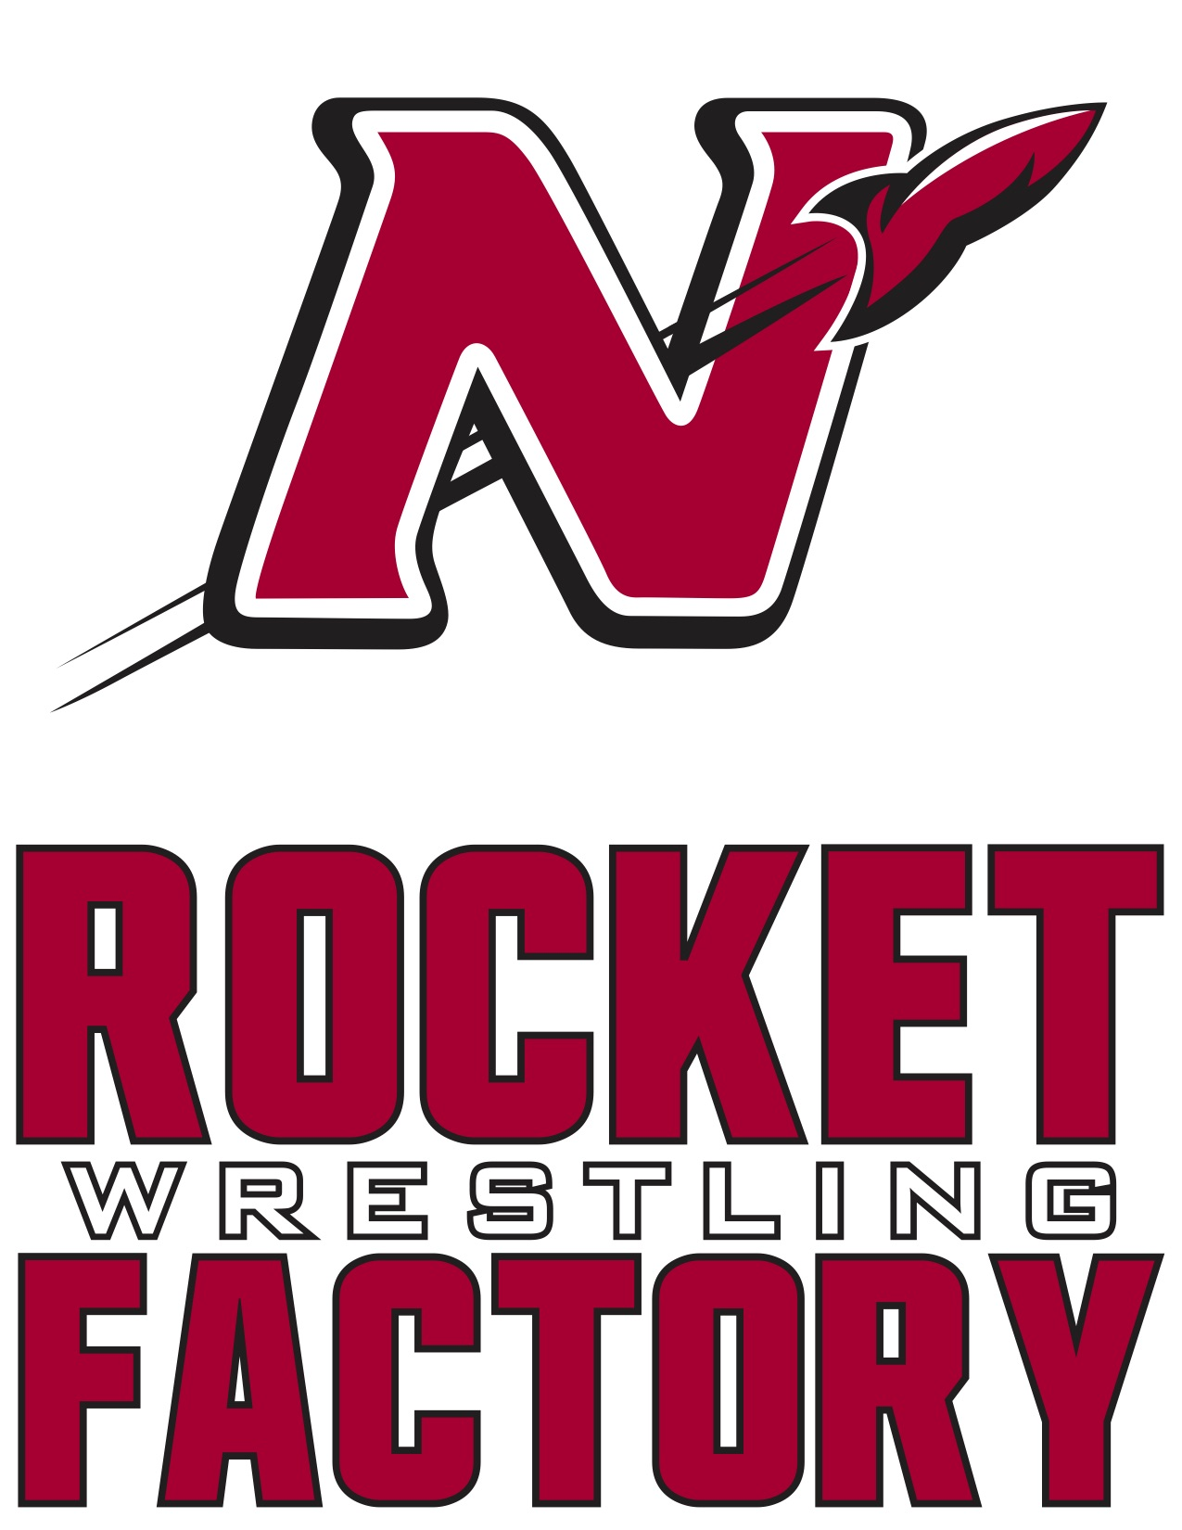

2021-2022 Schedule
Date Meet/Opponent Start Time Location/Site
Friday Nov 26th Thanksgiving Scrimmage 9:00 AM Denmark
High School

Thursday Dec 2nd Dual vs Hortonville 6:15 J.V. Neenah
*Business Sponsorship Night 7:00 Varsity High School

Friday Dec 3rd Kimberly Friday 5:30 PM Kimberly
JV Tournament High School

Thursday Dec 9th Dual vs Oshkosh West 6:15 J.V. Neenah
*Parents Night 7:00 Varsity High School

Friday Dec 10th Neenah Varsity 4:00 PM Neenah
Individual Tournament High School

Saturday Dec 11th Port Washington 9:00 A.M. Port Washington
J.V. Invitational High School

Thursday Dec 16th Dual vs Appleton North 6:15 J.V. Neenah
*Alumni Night 7:00 Varsity High School

Saturday Dec 18th Badger State 10:00 A.M. Alliant Energy
Depart 1:00 Fri 17th Varsity Invitational Center
hosted by Stoughton Madison, WI

Thursday Dec 23rd Dual @ Kimberly 6:15 J.V. Kimberly
7:00 Varsity High School

Tuesday Dec 29th Oshkosh on the Water 9:30 Varsity Kolf Sports Center
Wednesday Dec 30th Varsity Invitational 9:00 Varsity Oshkosh, WI

Thursday Jan 6th Dual vs Appleton East 6:15 J.V. Neenah
*Middle School/Youth Night 7:00 Varsity High School

Saturday Jan 8th WWCA Challenge Series 9:30 A.M. Neenah
Regional Tournament High School
Varsity Reserve/J.V.

Sunday Jan 9th Neenah Youth Tournament 9:15 A.M. Neenah
***HS Wrestlers required to work High School

Thursday Jan 13th FVA Double Duals Kimberly
Dual #1 vs Oshkosh North 6:00 High School
Dual #2 vs Fond du Lac 7:45

Friday January 14th Freedom JV Duals 5:00 PM Freedom
High School

Saturday Jan 15th Warhawk 10:30 Varsity Arrowhead Union
Varsity Duals High School

Thursday Jan 20th Dual vs Kaukauna 6:15 J.V. Neenah
*Senior Night 7:00 Varsity High School

Friday Jan 21st Highlander Friday Night 4:00 PM Homestead
Varsity Invitational High School

Saturday Jan 22nd WWCA Challenge Series 10:00 A.M. Wausau West
State Tournament High School
Qualifiers from 1/9

Thursday Jan 27th Dual @ Appleton West 6:15 J.V. Appleton West
7:00 Varsity High School

Saturday Jan 29th Mill City Melee 9:30 A.M. Shattuck
Middle School Duals Middle School
***HS Wrestlers required to work

Saturday Jan 29th Mill City Melee 9:30 A.M. Shattuck
Middle School Duals Middle School
***HS Wrestlers required to work

Saturday Feb 5th FVA Conference 9:30 A.M. Neenah
Varsity Tournament High School

Tuesday Feb 8th FVA Conference 4:15 P.M. Kaukauna
J.V. Tournament High School

Saturday Feb 12th WIAA Regional 9:30 A.M. TBD
Wrestling Tournament High School

Tuesday Feb 15th WIAA Team 7:00 P.M. TBD
Sectional Dual High School

Saturday Feb 19th WIAA Sectional 10:00 A.M. TBD
Wrestling Tournament High School

Thur, Fri, Sat WIAA State Individual TBD Kohl Center
Feb 24th, 25th, 26th Wrestling Tournament Madison WI

Friday March 4th WIAA Team State TBD UW Fieldhouse
Saturday March 5th Wrestling Tournament Madison WI
Home Duals and Tournaments in RED

