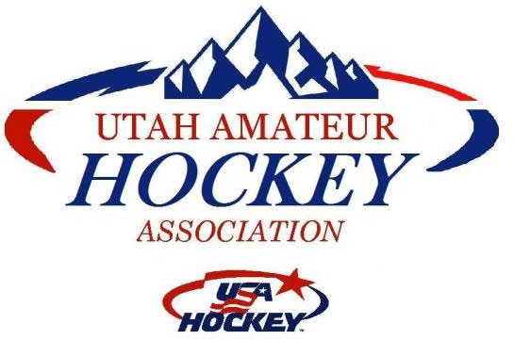

UAHA Regular Meeting Agenda
Date: March 6th, 2023
Location: Maverick Ice Arena Conference Room Zoom: https://us02web.zoom.us/j/83747140774 1-669-900-6833 Meeting ID: 83747140774

Regular Session: 7:00pm
- Roll Call : Bryan Nelson, DCHYA; Brenda Hickman, Provo; Jeff Tibbles, Park City; Jeff Kite, Jr. Grizz; Mariko Rollins, WCYHA; Erin Drecksel, Jr. Grizz; Sara Smith, Oval; Shannon Bennett, Growth Coordinator; Rich Lucy, DCYHA; Jared Youngman, Utah Grizz; Marc Van Komen, Lightning; Van Komen, Lightning; Jake, Peaks; Josh Anderson, Oval; Tamara Terrill, Oval; Robert Cowden, WR; Angela, Lady Grizz; Alex Velez, Safety Coordinator; Ryan Bonham, President; Jason Empey, Vice President; Foster Watabe, VP of Travel Hockey; Steve Wells, Treasurer; Misty Herbstritt, VP of HS; Chuck Dorval, VP of Girl’s Hockey; Tanner Ingalls, VP of Adult Hockey; Tim Odell, VP of Tier Hockey; Steve Picano, VP of Disabled Hockey; Shelly Strahan, Secretary; Robyn Eyre-Long, VP of Discipline/Registrar
- Approval of February Meeting Minutes Addendum A: The minutes passed unanimously.
- Development Pyramid Revision Addendum B: The pyramid has been slightly revised and some language added regarding the determination of how many teams are needed. The recommendation is to add any available teams into the structure. Robyn said that she would do that. The recommendation passed unanimously.
- Bylaw Amendment Approval: Chuck proposed that we approve them as they are and do clean up later. Robyn asked Foster if he found any inconsistencies, he said yes, that it should only say VP of Travel Hockey, rather than VP of Youth Hockey. Chuck said that there was also a mis-reference that needed to be corrected. Tim Odell seconded. The motion passed unanimously.
- Organization Approvals
  - House Rec D2: Foster motioned to approve all D2 teams in unlimited numbers for all age groups in all age groups who can host youth D2 teams. Jason seconded. It passed unanimously.
  - House Rec D1: Tim Odell motioned to allow all organizations to have as many D1 teams as they want. Steve Picano seconded. It passed unanimously.
  - Travel:
  - Girls: Robyn asked Angela if they would be having D1 and D2 girls teams next year. Angela said they wouldn’t know until they started and knew how many girls registered and what levels they were. Foster asked if a girl could play on a girl’s D1 team and a co-ed D1 team. Robyn verified that it was allowed. She then asked about timelines for teams jumping from one designation to another (Travel to D1, etc). Robyn said that she hoped that most teams would have their status figured out by mid-October. Foster said that should work. Chuck motioned to approve the girls travel teams at 12U, 14U and 19U and to add a girl’s 16U travel (it did not end up on the application summary) as well as 14U, 16U, and 19U Tier II teams. Foster seconded. It passed unanimously.
Youth: There are 6 18U travel teams, 7 16U travel, and 9 14U travel teams. 12U there are 10 requests, and 10U has 10 requests as well. Mariko said that all organizations should get as many travel teams as they can field. Misty asked what happens when a team almost fields, and then folds after all of the other teams are full. What happens to the players who made that team that folded? Jared Youngman said that happened to his player last year with the Eagles, and the Mustangs made room for his player on a team at the same level. Mariko corrected that she only wants 1 Travel team at 18U and 16U and 2 at 14U, 12U, and 10U. That correction was made. Rich Lucy said that Travel is still house rec hockey, and that house rec teams should not be limited in any way. Ryan Bonham said that the difference is that travel teams are allowed to go out of state as often as they want, whereas D1 is limited to 2 tournaments out of state. Tim Odell also pointed out that Travel teams can play up to AA tournaments. Foster clarified that he did request 2 18U travel teams and 2 16U teams. Steve Picano also mentioned that his Travel teams for Lightning could be removed. Foster motioned to approve travel teams as they are applied for (with Mariko’s corrections). Misty seconded. Alex Velez said that if the state website shows that the Lightning is granted teams, and then those teams are not fielded, it will create conflict. Rich said that he would hope that families go to org websites to see when tryouts are, rather than hoping that the pyramid will happen. The motion passed 5 to 4.
  - Tier II:
Girls: see above in Travel section
Youth: DCYHA, WCYHA, the Oval, Park City, Peaks and the Grizz applied for 14U and 16U Tier II, and everyone but Peaks applied for 18U Tier II. All applications were received by the deadline, everyone applied by the deadline of Feb 2, except Davis who submitted their application on February 15. There was supplemental information requested from some organizations. Once applications were complete, they were forwarded to the Tier committee on Feb 23, 2023. There were discussions had, and each member made recommendations of how many teams should be granted, and which organizations. Based on data from the Tier committee, Tim recommends 3 organizations be approved for Tier II hockey teams. Based on data from the Tier committee, Tim recommends that the board approves the Jr. Grizz WCHYA, and Park City. His recommendation is based primarily on stability (these orgs have had at least 2 Tier teams for several years), ice availability, and the promotion of players to the next level. Having too many Tier II teams does not promote the development of Travel players. Chuck said that he thinks that Tier II teams should be granted based on a metric and teams who don’t meet it should be demoted. Tim said that the discussion is already in place, and there were some rankings based on things such as organization status, progression of growth (development teams), win/loss ratio, etc. Foster asked if the demographic of where players live (who are on Tier teams) can be added to that. With Peaks, there were no Tier teams last year, and the Eagles only had 1 Tier team and no travel teams. The committee doesn’t feel that there is growth or ample players there to field teams for next season. Rich Lucy said that teams should not be limited beyond geographic programs. He said that Weber county recruited their coaches and players away from them last year, and then bought ice at the Maverick center to field it. Decisions should not be made on who has ice where. Tier II teams should be granted geographically. He is fielding calls from players who want to come back to the Eagles next year. He said that a Tier team should be granted for Weber, Davis, Salt Lake, Utah county, and Park City. Jeff Tibbles said that he is from the east coast, and played in Philadelphia area and in college and Europe. He said that Tier should be a free marked system, and that Utah doesn’t have enough talent to field 5 Tier II teams. The big issue is that Utah is constantly bleeding good Tier players out of state. Jake from Provo said that Provo has had strong A teams in the last few years. Because of the decision that everyone got a Tier team last year, those players scattered to try and join other Tier teams at other orgs. He said that he does agree with limiting the number of teams, but that orgs need to be encouraged to cover geographic areas evenly so that it is accessible to more players. Foster said that three teams is the right amount, and that no one is arguing that is wrong. He said that the question is which teams should be allowed to have Tier teams. Josh Anderson sad that he has no issue with being a feeder organization, but there are no Tier organizations wanting to work with this organization and partner with them to provide a place for his upper-level players to go. Chuck motioned that the Jr Grizz and Park City get 14U, 16U and 18U Tier II teams, but give the Eagles 14U and 16U and Weber 16U and 18U Tier II teams. Jared Youngman asked what happens when either the Eagles or Weber only fields 1 Tier II team. Ryan Bonham said that if that team won the state championship they would have to forfeit to the second place team. Ryan called for a second to Chuck’s motion. Chuck conceded his motion as there was no second. Tanner motioned that we follow the committee’s recommendation for Jr Grizz, Weber and Park City to have 14, 16 and 18U Tier II teams. Tim Odell seconded the motion. Misty said that she is concerned about Weber getting three Tier II teams. She said that she has already had people approaching her asking what recruiting is. Josh Anderson said that if there are too many Tier II teams, then there are not enough travel teams at the upper age groups. It passed 6 to 3 with one abstention.
- Utah Rebels New Org Application: The Utah Rebels is an organization that helps to raise money for youth hockey. With the Lightning choosing not to do travel teams, the Rebels would like to pick up the travel teams and have 10U, 12U and 14U travel teams. They have already secured ice and coaches if approved. They want to apply the ADM to their practices. There are projected costs listed in the application. It will cost around $2100 per kid to be able to play 28 weeks of hockey, that includes uniforms and game costs. Jason Empey motioned to deny the application based on the fact that there is no proof of development, and the organization appears to be built around three specific teams of players. Shelly Strahan seconded. It passed with 9 for and 1 abstention.
- Section Reports This part of the meeting will be skipped
  - High School VP, Misty Herbstritt
  - Girls VP, Chuck Dorval
  - Adult VP- Tanner Engles
  - Youth VP (House/Rec) Foster Watabe
  - Travel VP (Tier), Tim Odell
  - Disabled VP, Steve Picano
  - CIC/ADM, Michael Strahan
  - Goaltending Development Coordinator, Jared Bussell
  - Safesport, Wendy Radke
  - Safety Director, Alex Valez
  - Membership Growth Coordinator, Shannon Bennett
  - Web Master, Brian Murray
  - Registrar, Robyn Eyre Long
  - Discipline, Robyn Eyre Long
  - Treasurer, Steven Wells
  - Secretary, Shelley Strahan
  - Exec, VP, Jason Empey
  - Past President, Derrick Radke
  - President, Ryan Bonham
- Next Meeting, April 3rd
- Adjourn Meeting

UAHA Regular Meeting Agenda
Date: February 6th, 2023
Location: Maverick Ice Arena Conference Room Zoom: https://us02web.zoom.us/j/88516052789
1-669-900-6833 Meeting ID: 88516052789

Regular Session: 7:00pm
- Roll Call
Attending: Ryan Bonham, President; Shelly Strahan, Secretary; Robyn Eyre-Long, Registrar/VP of Discipline; Tim Odell, VP of Tier Hockey; Steve Picano, VP of Disabled Hockey; Tanner Ingalls, VP of Adult Hockey; Steven Wells, Treasurer; Misty Herbstritt, VP of HS; Alex Velez, Safety Coordinator; Jeff Tibbles, PCIM; Erin Drecksel, Jr Grizz; Shannon Bennett, Growth Coordinator; Josh Anderson, Oval; Sara Smith, Oval; Jeff Kite, Jr. Grizz; Evan Stoflet, WR; Foster Watabe, VP of Youth Hockey; Mariko Rollins, WCYHA; Tamara Terrill, Oval; Morgan Richardson, AVAHA; Paul Lehman, Parent; Angela Steinbach, Lady Grizz; Robert, WR; Brenda Hickman, Provo; Danny LaDue, Jr. Grizz; Chuck Dorval, VP of Girls Hockey; Cherei Miller, AVAHA; Yvette Connelly, PCIM; Jacob Hickman, ;
Absent (Board):
- Approval of January Meeting Minutes Addendum A:
Tim Odell motioned to approve, Tanner Ingalls seconded. It passed unanimously.
- Tier 1 Application 2023-2024
The Tier committee discussed the Tier I application from Wasatch Renegades, and it was approved by the Tier committee. The application was due on Jan 15, 2023. WR is applying for 13U (new through USA Hockey), 14U, 15U, 16U, and 18U. Discussion was opened. Paul Lehman asked Evan how many students would return. Evan said he wasn’t sure, and Ryan Bonham mentioned that recruiting was locked down until 24 hours after the National Tournament ended. Paul Lehman asked if they had their ice scheduled. He said that it was a requirement for applications. Ryan mentioned that it was just for new applicants, not returning applicants. Paul Lehman also mentioned that he did not feel that WR was providing true Tier I hockey, and that the board needs to hold them accountable. He asked the board to look at the turnover for the organization this year. Tim Odell said that all of those things can be said about many of the other Tier I teams in the nation that WR is playing.
Ryan Bonham said that players need to be pushed up to that team, not recruited down to other teams. Tanner motioned to follow Tim and the Tier committee’s recommendation and approve the application by the Wasatch Renegades. Tim Odell seconded. It passed unanimously.
- Development Pyramid Modifications Addendum B and Spreadsheet Attachment
Tim’s committee was tasked with making modifications to the development pyramid for UAHA. They are proposing 5-10% of players at Tier I, 10-15% Tier II, Travel 25-30%, and Recreation 45-60%. That gave a recommendation for 1 Tier I team, 2-3 Tier II teams (except 18U, which should have 1), and 4-6 teams Travel teams at each age group. He also took the 16U/18U High School data off, because it skews the data. HS numbers have been fairly consistent, with peaks at 14/15 and dropping off from there. He said that he thinks that the pyramid should be analyzed every two years, but it is just a matter of looking at two years’ worth of numbers in the spring. Ryan pointed out that there must be at least 2 Tier teams per organization (that has Tier teams) in order to be a national bound organization. Paul Lehman said that 40 16/18U players who left the state this year. The wording is as follows: “Based on using the UAHA 2022-2023 Targets for % of players for each level of play by age group the Tier Committee expanded the
%’s and used the 2022-2023 registrations by age goup to determine amount of qualifying players by level. For example the 2022-2023 UAHA target for Tier I was 5%. The Tier Committee expanded the range to 5%-10% of players. By multiplying the low and high

percentage of players by age group will yield a low to high range of total players. Using the recommended roster size of 15 players, the recommend number of teams was arrived at.
Based on the above rationale, for Tier I it is recommended to approve 1 team per age group and for Tier II it is reccommended to approve 1 team at 18U and at a minimum 2 or a maximum of 3 Tier II teams for the 16U and 14U age groups. The Tier Committee did not make
recommendations for the number to Tier II teams for females nor did we expand our recommendations for travel and youth levels.
This recommendation should be for the 2023-2024 and 2024-2025 seasons. A subsequent review for the following two seasons using the 2024-2025 data as a determining factor for the # of teams.”
Ryan Bonham suggested that the wording be changed so that it does not say that the Tier committee recommends, but rather, that the policy is as stated… That would also mean removing the section about the women’s hockey. The Lady Grizz representatives asked about using the same percentages for Girl’s hockey, as that would mean they didn’t qualify for any Tier teams. Tim said that separate language could be added specifically for the girls teams so that they would continue to be able to field teams as appropriate. Mariko asked about being able to put a pause on this change, and to count ISI players and out of state players as part of the count. Ryan said that this adjustment affects 14U to 18U more than the other age groups and that the data for the younger players can be considered at a later date. Tim Odell asked how the players out of state affect these numbers, as they aren’t playing in state. Mariko said that she wanted to look at more complete data, as there were a number of players that left because they thought that they wouldn’t be able to play for the one coach they all wanted to play for. Mariko clarified that she just wants more complete data, not to postpone the vote or argue. Ryan Bonham said that Robyn did pull that data that included the out of state players a couple of months ago, and that he would be happy to send that out. Paul Lehman suggested adding some qualitative language, to give the board discretion, in case something changes. That way, if a bunch of the 40 players out of state come back, the board could add a team if they felt it necessary. Ryan said that adding subjective language is what caused our issues last spring, but that objective language makes it more fair. Ryan recommended that Tim create actual redline edits that can be sent out. He said there is no actual vote necessary, everyone just needs to be on the same page.
- Lady Grizz is asking to add Adica Nielson Addendum C:
It is after the roster freeze, however, the 19U Lady Grizz would like to add her to their team, which is not a National Bound Team. Adica started playing for the Lady Utes, however, due to personal circumstances she is no longer eligible to play for the U of U. The 19U team would like to add her on. They are playing 19U A hockey, even though they are not an A level team. There are other girls teams in the same situation. The team is made up of 14U, 16U, and 19U girls who are not playing on the existing Tier teams. There were originally 16 girls on the team, one was let go because she wasn’t making it to practice. There is one goalie, and in the last tournament she faced 175 shots.
They feel that adding Adica would help boost team morale and would add to the team. Ryan asked if having a tournament team would solve the problem. The Lady Grizz coach said that he understood that was just for D2. Ryan said that wasn’t a hard and firm rule. The Lady Grizz coach said that skill wise, the team was D2, not Travel, it just had to be classified as travel since there isn’t house/rec girls hockey at that age. Steve Picano made a motion to approve a tournament team roster for the 19U Lady Grizz. Jason Empey seconded. It passed 10 to 1.
- Winter Meeting Report (Ryan Bonham):

  - Takeaways: We have been working on Travel A and B, as well as the tournament that includes rec hockey. In Texas, rec hockey skates 1 time per week, and stayed in house. They also have a la carte skates, where the players are officiated in small area games by coaches, so that rec players can have more skates if they want to. The Dallas Stars have built 14 rinks in the last 10 years. They have one Tier I team and have been sued by an organization that wants another Tier I team. They are going to add another Tier I, but not the organization that is suing. Colorado currently has 4, but they are moving to 3. Texas does not allow for billet players from out of state. Texas uses the ADM model for their junior stars program. Josh mentioned that Texas has a solid in-state league, which Utah doesn’t have. Steve P said that the orgs should be restricting the times that their teams go out of state, that it shouldn’t fall just to the state board.
  - Continued Growth Discussion: As we look at Travel A and B with the rec program below that, we need to consider that it is not just skill that separates Rec from Travel B, but also a desire to get better.
  - Recruiting reminder: There was a letter sent after the winter meeting, talking about recruiting deadlines. Tryouts for all Tier I and II, 14U to 18U Youth and 19U womens, can start any time after 3:45 p.m. Eastern time on April 4, 2023. No Tier teams may hold development camps, tryouts, recruiting, etc before that date. Any violation may subject the coach, team, program or administrators to discipline or ineligibility of the team as per USA Hockey. This applies to players already in the program as well. Mariko asks if there is a list of appropriate questions for end of year surveys, so that orgs don’t get in trouble. Ryan said that all he had was the rule, and to just make sure that no questions could be framed as recruiting. Once organizations are approved, they have to have tryouts approved, and the state gets to help regulate tryouts in addition to the national rule. Steve asked if he could send the rule out, Ryan said he would. Tim asked if it could be put on the website, and Ryan said yes. Josh asked about summer tournament teams. Ryan said don’t recruit. Erin Drecksel asked about spring ice. Ryan said that they should not start until April 5, 2023.
- Upcoming Scheduled Items: Org applications deadline has passed.
- Organizations applications and approvals: In March, the board is deciding on Tier II, Travel and other approvals. Foster mentioned that people might not be fully prepared for the A/B split during the application process. Ryan said that he felt that those teams could be left open. Paul Lehman asked if there are any quality metrics that will be involved next month. Ryan said yes. Steve suggested that Paul bring everyone pizza.
  - Voting for Board Candidates and nominations: Candidates will be decided in March. Tim Odell said that teams need to be approved, then go do research, and find their ice time for tryouts. Ryan asked if he can have the Tier committee recommend Tier teams, and a tryout schedule. Tim said he can get feedback, but there are Tier orgs on the committee, so they shouldn’t be deciding on who gets teams. Once teams have tryout dates, they can come to the board for approval. Ryan asked that they have tryout dates for the April meeting.
  - Bylaw voting: In March
  - Tryouts schedule: Will be approved in April
- Section Reports
  - High School VP, Misty Herbstritt: Playoffs are happening right now
  - Girls VP, Chuck Dorval: There is an all-star game, plus an all-star girl’s invitational game. It is at Steiner. It is HS girls. 10s and 12s are wrapping up the season, 14Us had league championship, 16U girls won their league championship in Denver this year. Districts coming up in the next couple of weeks.
  - Adult VP- Tanner Engles: He has focused on registrations this month. Mariko gave him a gold standard application letter. He used it as a template for the other orgs. Park City, Amanda, also did a great job reaching out to Tanner and working with him. Tanner asked why there is no adult representation from Provo, even though they have a lot of players. Tanner said that he is working on incentivizing players to come back to USA Hockey.
  - Youth VP (House/Rec) Foster Watabe: The youth organizations are amazing, the URHL tournaments are coming up. They are over the number of teams from last year that are registered for this year. They are working to make sure that they have enough ice. PCIM is thinking about changing their High Mountain Shootout Spring tournament to a year end travel tournament. Provo will also be helping with ice for that.

  - Travel VP (Tier), Tim Odell: State championships are happening the first weekend in March. Hats are being ordered for the championship teams, same design as last year, just different dates.
  - Disabled VP, Steve Picano: There were great numbers last Thursday at sled hockey, there are three more Thursdays to go. If anyone has questions about state camp, please reach out to Steve and Steve only. Please do not use his work email. Yvette said that registration is going fine. Steve has hotel rooms for the out of state coaches, and he is working on getting an out of state person for goalies as well. Angela Steinbach asked if the girls were getting out of state evaluators as well, and Steve said no. He said that he has several new in state people who will be evaluating the girls who don’t work with the girls program here in state.
  - CIC/ADM, Michael Strahan:
  - Goaltending Development Coordinator, Jared Bussell: Absent
  - Safesport, Wendy Radke: Absent
  - Safety Director, Alex Velez: No concussions have been reported. Alex Velez said that all orgs should have a safesport rep who should be reporting concussions to him as Safety Coordinator. Also, coaches need to make sure that they have a doctor’s release before they skate again. Alex Velez said that if there is a player who cannot get in to a doctor to get cleared to contact him and his clinic that he works for can help. The forms are all on the UAHA website.
  - Membership Growth Coordinator, Shannon Bennett: She is excited about the winter meeting ideas that Ryan has brought back. She has been working on Try Hockey for Free. Last Thursday USA Hockey announced the Try Hockey for Free national events. Some of the orgs were not aware of this. She has been talking with Mariko, Foster and Steve, trying to get those on the schedule. Feb 25 is the next National Try Hockey Day. Many of the rinks are running try hockey on different dates due to scheduling. There is a girls only Learn to Skate over President’s Day at Steiner. There are 11 girls signed up so far. They will have an all female staff out on the ice. Millcreek Commons has a facility with an outdoor ice rink. Shannon has helped Shannon Schmidt run an NHL try hockey program through the LV Knights. For 200.00, a family gets the ice and the gear. There has been good retention in states that have done it. She would like to talk with Jared and see if they can get something set up at the Maverick Center. Also, educating our market (all people in Utah) is important. Shannon has spoken to many people who have no idea what gear is needed, how the game is played, etc. Mariko has been doing Zoom meetings with her program and she has coaches, doctors, etc doing seminars. Foster asked if she has a list of topics. Shannon said she would ask.
  - Web Master, Brian Murray:
  - Registrar, Robyn Eyre Long: She is working on credential books for National Bound teams. They take her about an hour per book to go through. Please submit them as soon as they are completed, don’t wait for the deadline. USA Hockey reg fees will remain the same for next season. 18U Tier I can now have 22 on a roster, 20 plus 2 goalies.
  - Discipline, Robyn Eyre Long: Discipline has been pretty quiet. Standardized penalties has helped. Please remind coaches about the code of conduct.
  - Treasurer, Steven Wells: No updates.
  - Secretary, Shelly Strahan: No updates

  - Exec, VP, Jason Empey: No updates
  - Past President, Derrick Radke: Absent
  - President, Ryan Bonham: See above Winter Meeting update
- Next Meeting, March 6th
- Adjourn Meeting

Addendum B
PROPOSED AGENDA ITEM SUBMISSION FORM
NAME OF PERSON SUBMITTING AGENDA ITEM: Tim Odell

PROPOSED AGENDA ITEM: Tier I and Tier II Developmental Pyramid Recommendation

DATE PROPOSAL SUBMITTED: February 27th, 2023

MEETING MONTH AND YEAR: March 6th, 2023

DESCRIBE PROPOSAL: As a follow up to the February 6th, 2023 regarding further defining the Developmental Pyramid so that the UAHA BOD can use the information as a guide for determining the amount of teams at each level.
REQUESTED ACTION: Propose the following modifications to the Policies and Procedures effective for the 2023-2024 Season:

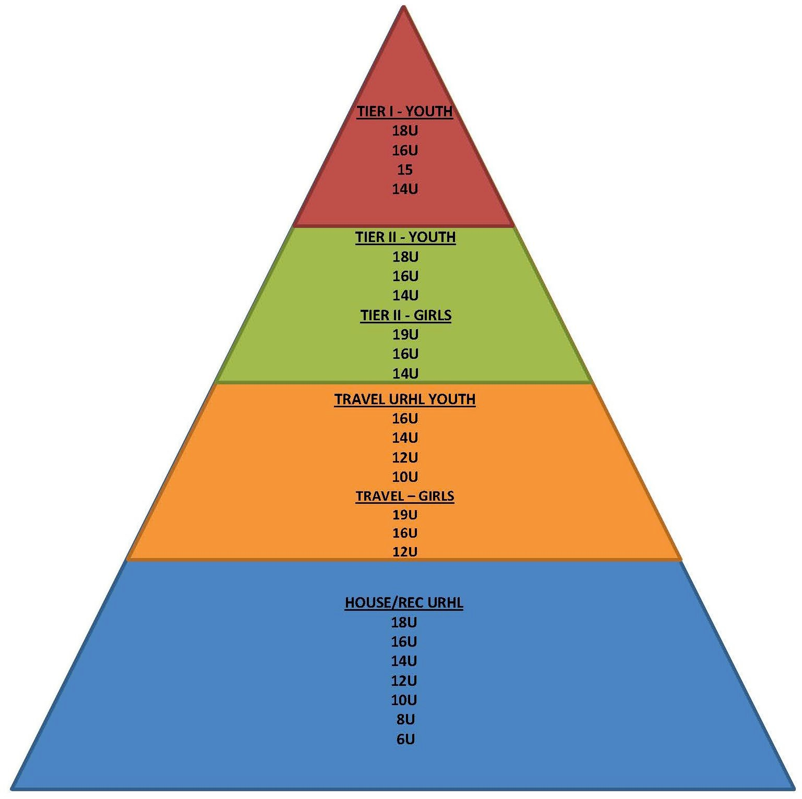
Teams are determined each season. The approved teams are posted on the main page of the UAHA Website at www.utah-hockey.com. Team approval is based on BOD determined ration that approximates the ideal USA Hockey pyramid. UAHA has determined only one (1) Tier I team at each age level is the maximum allowed until the skill level of players as a whole significantly improves. The recommended guidelines shall be used to determine the amount of teams per level and age by multiplying the total players in each age group by the UAHA Target Goals. Female only teams are excluded from utilizing the developmental pyramid to determine teams at each level.
UAHA Target Goals

Tier 1

5%-10%

Tier II 10%-15%

Travel 25%-30%

House / Rec 45%-60%

