Section | Sub-Section | Discussion Key Points | Action Items and Decisions
Approval of Minutes | December 18, 2019 | Call to order at 5:08 pm. | Strain moves to approve, Lindgren seconds. Motion passes.
President’s Update | Transition Process and Plan | Rossi and Al met to transfer key documents and discuss specifics around evaluations processes to prepare for the year. Al will be sorting through files and transferring remaining documents in the coming months.  Additional plans include a website overhaul and update, updating the format in which minutes are documented, and modifying the agenda order to focus on time-sensitive priorities. Rossi will also create a “handbook” with what to do, when, how, and why so people can step into roles and pick up tasks without a lot of start-up time.  Al will continue to serve as “acting commissioner” for the 8U Northern League until it is up and running this season. Communication with partner associations has begun.
 | Fence Project Fundraising Update | The full sum of $1500 has been raised thanks to Eric Rice (14-U Adriana’s dad), who is the president of the charitable gambling board at St. Maron’s church. They sell pull tabs at Big Louie’s, and have donated $1000, in addition to the previous $500 anonymous donation. | Information only.
Finance | Treasurer’s Report | Nothing to report.  Lindgren is tracking on last year’s budget.
 | 2020 Budget | Need excel sheet from Al;  Anticipated significant departures from last year:  - Increase in umpire cost  - Decrease in equipment expenditures  - Fence project | Get prelim budget from Al; Rossi/Erik to discuss offline for next meeting.
New Business | Evaluations Day | - Timing/Structure  - 10U 9 - 10:30  - 12U 10:30 - 12:30  - 14U/8U 1:00 - 2:30  - Volunteers - Andrew working on sign-up genius  - Scoring  - Pitchers - discussion about pitching evaluation and using outside evaluators. Consensus that pitching evaluations and weighting of pitching elements.  - Review of pitching catching team selection form and discussion about modifications to be made for 2020.  - Catchers - less time needed. Need to be cognisant of coaches evaluation.  - General -  - Need designated person to explain the cage process (i.e. 2 bunts, 10 swings) - this adds volunteer  - 2 rounds of tag out, 2nd round with ½ of the reps  - Only need 1 volunteer at running station for 12U and 14U  - Evaluators  - 8U - Are we getting an appropriate return on investment of the volunteer and gym time for 8U evaluations? What can we change to make it more efficient?  - Consensus that 8U evals are moved to the end of the day; combine 8U and 14U upper/lower gyms. 8U kids requesting to move up to 10U will only need to evaluate at 10U. | Action item: Danielle and Sara to bring pitching lanes to test at next clinic/open gym for potential use at evaluations.  Action Item: Danielle to bring radar gun to evaluations.  Action Item: Andrew and Danielle to reach out individually to past volunteers prior to general sign up and create/update coverage grid for this year.  Action Item: Rossi to reach out to  - captains/hs players about helping evaluate 8U kids.  - Also HDC members re: catching evaluations.  - Rossi to send info re: registration requests to play up, and pitching/catching  Macalester Independent Evaluators confirmed by Danielle  Rosha confirmed for Catching evaluations. Need 2-3 additional evaluators.  F/U meeting re: pitching evaluation rubric. Strain to email previous pitching eval forms.  Action Item: Update pitching/catching selection form to reflect 33% pitching time is for league and pool play, but bracket play is coaches discretion.  Decisions: Combine 8U and 14U evaluation time, release 8U kids requesting to play up from 8U evaluations. Schedule as noted in discussion column.
 | Coach Selection Committee and Application |  | Katie confirmed for coach selection committee board member representative.  Rossi to ask Renee, Amy Kudrowski, Melissa, Jeff, Lamar, Al
 | Evaluations Committee |  | Rossi to ask Lamar, Jeff, Melissa, Jeff P.  Sara confirmed.
 | Clinic and open gym staffing review | Jan 26 MFA - Rossi to open, Sara to close  Feb 1 Open Gym  Feb 2 MFA - Andrew to open, Sara to close | Rossi to confirm gym time and space, reach out to request volunteer coverage to free up coaches for coaching conference.
 | Creation of additional open gyms | Work on open gyms after evaluations.
Coordinator’s Updates | Player and Coach Development: Danielle/Rossi | NFCA Conference is at the Airport Hilton on 1/24 - 1/25, cost is $139 before 1/9, $149 after.  2020 Play Ball! Softball Coaching Conference (sponsored by MN Twins) is Feb 1 from 8 - 3pm. Cost is $30 and includes breakfast, lunch, and Twins tickets.  Rossi has a potential new catching workshop contact - D1, and now semi-pro catcher Olivia Huffman. Will return from NZ in late April. Interest in setting up a catching clinic in late April/early May?  In-house coaching clinics?  In-house pitching clinics? Yes - | Rossi to email coaching roster info about conferences.  Rossi and Danielle to f/u re: pitching clinics
 | Equipment: Erik/Rossi | 5 buckets of softies have been taken from the equipment room for the MFA clinics - Rossi has them  Interest in purchasing a pitching lane for evaluations? $190 on Amazon - try before we buy  Need some new bags for team equipment.
 | Fields: Steve | Nothing to report
 | Umpires: | Need Umpire coordinator for fastpitch and 8U  Derek will follow up with Sara re: notes and processes
 | Spirit Wear: Erik | Erik had a successful and productive meeting with The Graphic Edge. There are significant benefits to using TGE for an online store this upcoming season, and they are also available for uniforms.
 | Uniforms: Erik | Erik is obtaining sublimated sample and screen print sample.  Proposal to purchase new uniforms for 10U players with 12U players needing a new size purchasing their own. Questions raised about the number of players would want a new jersey at 12 or 14U, and what the threshold is for purchasing all new uniforms.  One idea is to ask at evals whether people would be willing to cover all, half, or none of the cost of a new jersey.  Another idea is to purchase sublimated for 10U and have players purchase look-alike screen print for 12U and up (hybrid approach).  Tabled to future meeting.
 | Fundraising: Rossi/Erik | Croc Charms - Econo Promos does custom croc charms for $3 each.  Danielle coordinated with player June McGrath about ordering custom scrunchies. Booster’s cost would be $3.50 each.  Custom Scrunchies can be ordered from ElasticBandco.com for $2.95 each, minimum order $100, free proof and layout, 12-15 day turnaround.  Erik coordinated with X-Grain and has obtained 4 mock-ups:  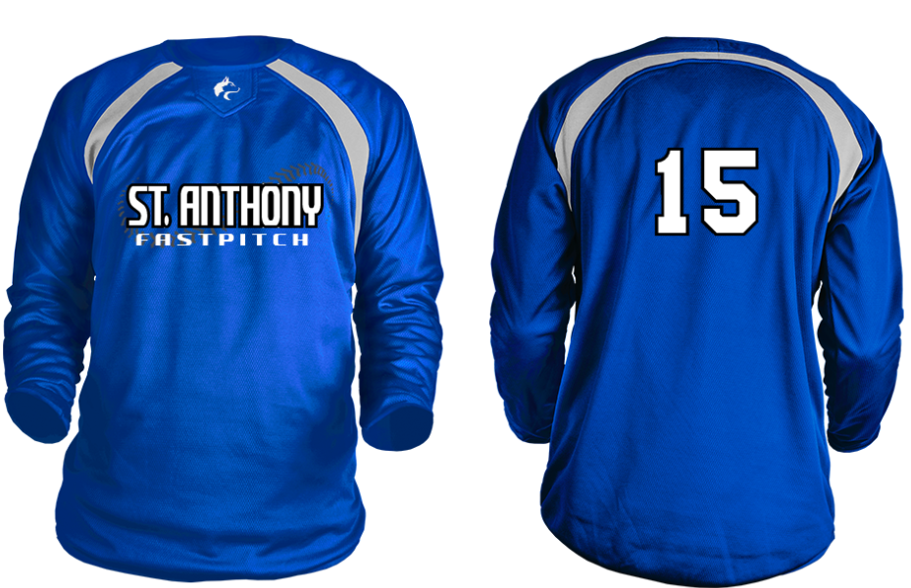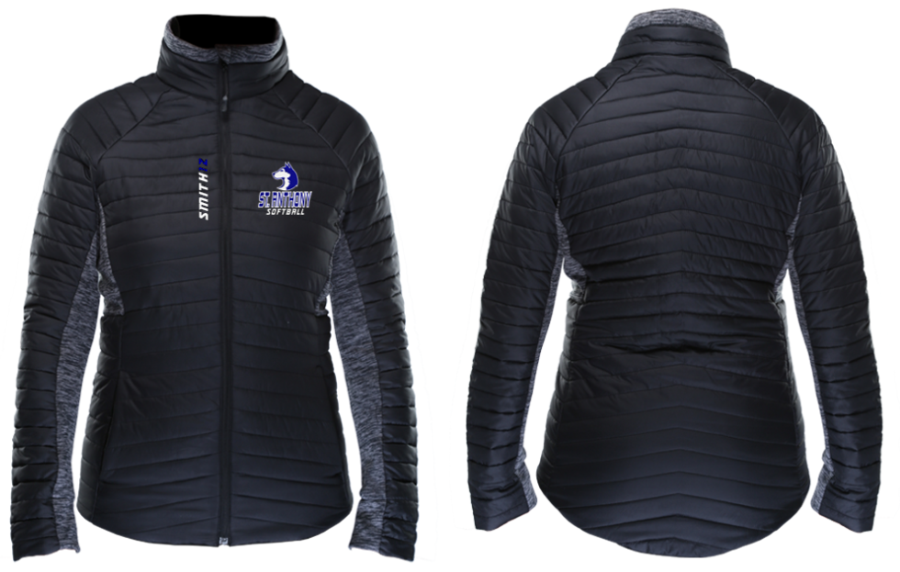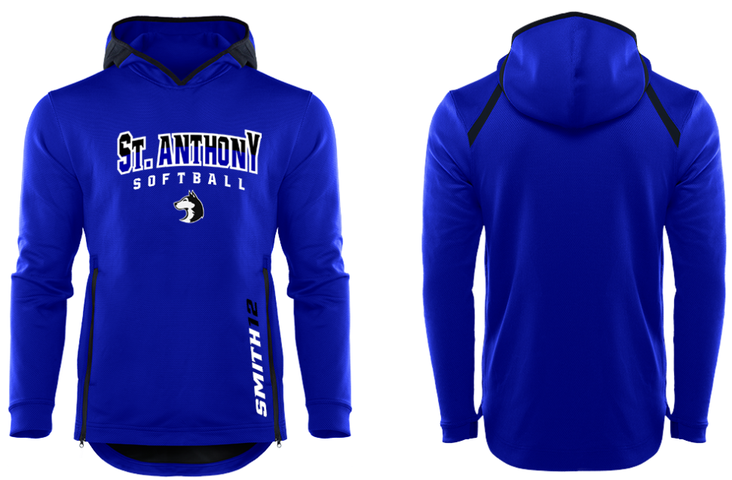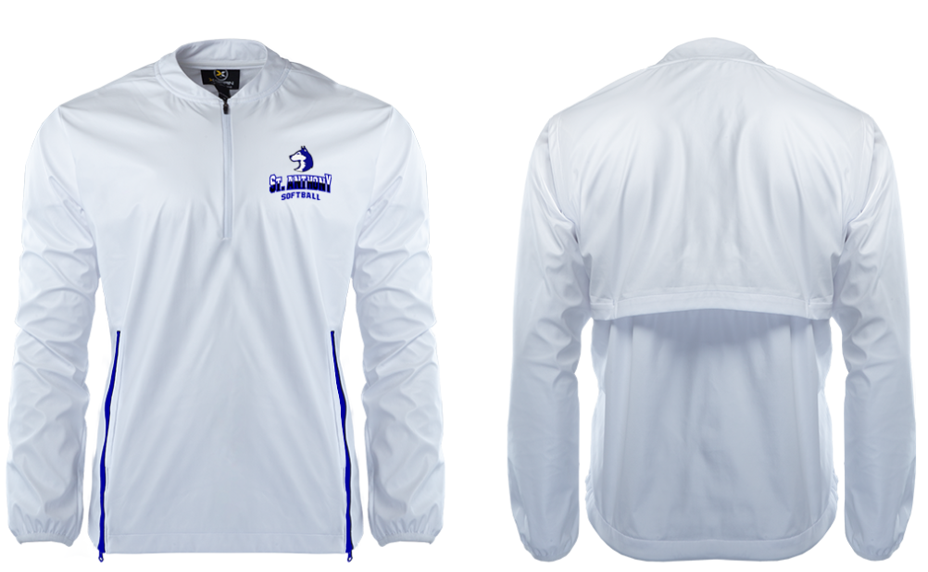  Other ideas?  Headbands and water bottle stickers | No to croc charms or scrunchies, more follow up on headbands and water bottle stickers.  Offer i4 x-grain options at evaluations.
 | HDC Liaison Update | Rossi reached out to Jeremy with the following questions:  - Will the HDC be buying or selling helmets again this year?  - Will there be a 4th/middle school team, or just Varsity, JV, and C?  - Do you have a sense of whether or not there will be a 16/18 team this spring, and if so, do you expect that to impact any natural age 14U players?  - Is there any other gear (bags, jackets) that the HDC will be offering/providing HS players? If so, I will avoid duplicating what we offer in our online store.  There hasn’t been a response yet, but Rick Ballot did reach out to Al to discuss 16/18U registration, and the form has a 2/1 deadline. This should enable us to plan our teams without  1/6/2020 update: Coach Lamar has invited all 9th graders to play up at 16U.
Old Business | Gym Time Use Matrix | No update | Rossi to create
Parking lot | Documents from Al | Budget information
Future Meeting Dates |  | January 19th, 5:00  Meeting adjourned at 8:06 pm.

