Plano West Baseball Booster Club
MEETING
January 17, 2023
Minutes of the Plano West Booster Club Meeting, Plano TX, all on online

CALL TO ORDER

Board member Jeff Pascal called meeting to order at 6:33 pm
Board Members Present: Jeff Pascal, Nelsy Mele, Valerie Morton, Julie Raecek, Erin Wasson
Board Members Absent: n/a

Coaches
Coach Clark
Coach Zastoupil

Participants
    - Natalie McDaniel
    - Danielle McCormick
    - Sam Morton
    - Tatiana Buriko
    - Elizabeth Jacobson
    - Jonathan Putt
    - Paul Nhem
    - John Szeliga
    - Angela Thompson
    - Jeffrey Moore
    - Jenny L. Martinez ​
    - Jim Caulk
    - Eileen Little ​
    - Gerilyn Laurence
    - Ginger Cox
    - Teresa Marquez de la Plata
    - Darin Marshall
    - Katie Kilmer ​
    - Sarah Long
    - fwang999@hotmail.com
    - Endren Tran ​
    - JOHN GORMAN JR
    - Tim Liu ​
    - Chris Grimes
    - Kara Grimes
​
REMINDERS
- Please download SportsYou from App Store and sign in using our code below. The majority of communication during the season will come from here.
- PWBB Code: DCMN-ZE9D
- Please remember to join the Booster Club

UPDATES
- Amber DePauw (Secretary) has moved and therefore a new secretary was appointed by the Board. Moving forward, Erin Wasson will serve as Secretary.

MEETING MINUTES APPROVED (DECEMBER)
- Meeting minutes were posted on the site
- Motion to approve: Sam Morton
- 2nd: Elizabeth Jacobson

TREASURER REPORT
Jeff Pascal gave the report as follows:
- Our Beginning Balance: $25,313.69
- New Income: $2,195.42 ($2,195.45 Golf – Paypal account transfer)
- Expense: $0.00
- Current Balance: $27,509.11
- Nelsy produces income statement if you want more details

CALENDAR
This is when we get running. Please get involved and volunteer and stay up to date with communication.

- First workday has been completed
- January 20th – Blue/White Scrimmage (Varsity/JV)
- January 2st – Sponsorship Strategy
- January 27th – Players to take all things home out of lockers
- January 28th – Media Day (players) & Work Day (parents)
- February 4th – Workday*, 1st scrimmages
- February 21st – First Pitch Dinner
- April 30 - End of Season Banquet @ Marriott

THEME NIGHTS

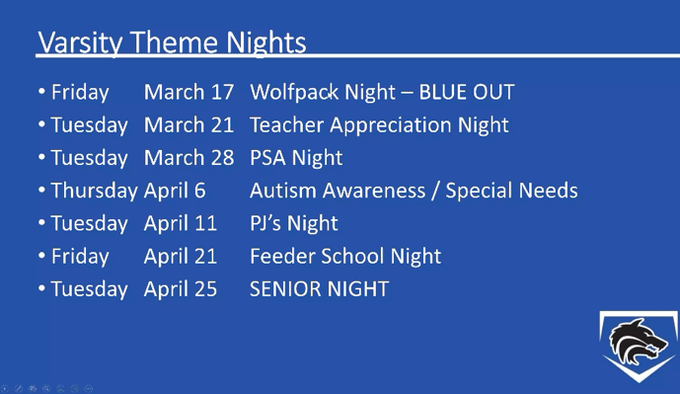

- Jeff reached out to PSA and this is not confirmed but hoping we can get it on the calendar
- Autism Awareness and Special Needs night was done last year and we are now going to take it to District Game
- Feeder School Night will be a combo of Middle School and Elementary Schools
- We will need help with the nights
- First Pitch Dinner:
  - Need 5 parents for First pitch dinner (centerpieces, setup tables, small takeaways for parents, set up and take down). Please message Julie Raecek, if you are interested. Noted in meeting/chat:
      - Elizabeth Jacobson
      - Teres Marquez de la Plata
      - Jenny L. Martinez
      - Ginger Cox
      - Natalie McDaniel
- Theme Night Task Force
  - Need Parents to be involved with this
  - Prefer JV and VARSITY parents for this as JV2 will be away
  - What’s involved – event planning of each night with communication, planning run of show, etc.
  - Robin Paschal will be playing point on this (Erin Wasson to help her)
  - Need Volunteers:
      - Ginger Cox
      - Natalie McDaniel

CONCESSION
- There is an expectation that every player has one parent to work one game (approximately a three hour commitment). If we get that commitment, our concessions will be covered.
- Julie will send our SignUp Genius for all games
  - JV2 will be working concessions at the same time you are playing so try to do buddy system to rotate so you catch your player at times.
  - JV + VARSITY Nights – We would like Varsity Parents to work JV games and JV parents to work Varsity games.
  - Elizabeth Jacobson will get SignUP Genius to Shepton and West NJHS (there always need to be one adult with the students)
  - Volunteers from Chat:
    - Tim Liu
    - John Szeliga -select dates
- We will be simplifying the menu this year
- We will start taking donations of Bottled Water, Gatorade, Soda & Chips starting this Friday so when you come for Blue & White Scrimmage please bring a donation.

GAME DAY MEAL COORDINATORS NEEDED
- On Game Days we will have meals (that are paid for individually by each plyer)
- We need 2 people per team – you will need to place and deliver orders.
- Julie has a full overview of how it works for those that volunteer.
- We will be keeping Canes but will be looking for a second option.
- Volunteers:
  - Tim Liu Volunteered

SCOREBOARD & GAMECHANGER
- Need for each of team
- Coach may have someone suggestions on who will run GameChanger
- If you are volunteering please come to Blue & White scrimmage so we can have a tutorial on scoreboard
- Volunteers from Chat for Scoreboard:
  - Darin Marshall
  - Carlos Marquez

JV & JV2
- Looking for announcer and music

SPONSORSHIP SATURDAY
- Intent is to get the kids and parents in the community to garner support and awareness of our program
- The Morton’s have routes, scripts, lists – we are looking for businesses to be sponsors, provide cash or in-kind donations
- We want this to be a team building activity
- This is our largest push we need a few more parents to volunteer (signup for parent volunteers and players is in SportsYou.
- We need 8 total parent volunteers:
  - Chris Grimes
  - Johnathan
  - Alex Cox
  - Jeffrey Moore
- Role of parent is to keep the kids on track and collect the money if they do get cash donation
- Want this to be player led but need supervision
- Please wear PWBB attire (t-shirt or sweatshirt and black pants or shorts)

COACHES CORNER

- Thank you to everyone who is on the meeting tonight. Appreciate your continued help with the program. This is a big meeting with lots of volunteer information, if everyone can just pick one project and one game day it will all get done!
- Very excited that it’s time for baseball! Offseason has led us to this point. We are ready for long practices to begin.
- Coaches Convention in Round Rock was great. Lots of ideas and they brought in a coach from Virginia that was awesome – enthusiasm, pace of play, some great drills
- Moving forward this point is when Baseball becomes a 6 day/week commitment
- We will let the boys know by Thursdays if we will be practicing on Saturdays and what time…will usually be 8 am – 12 pm/1 pm (we will have some Saturdays off but that’s a bonus)
- Every day during the week we will finish around 5:45 – 6:15 pm
- Once we get to games, practices will not go as long
- Our Spring Break is Baseball - Spring Break is when we are doing our final District Dress Rehearsal, players should plan to be here over Spring Break
  - We understand if there are life things or medical things.
- Cardinals Gear is in…handed it to the boys on Tuesday. Belts will follow.
- We need to get media day pictures done but there will still be fluidity to teams - this will be a case by case situation.

Questions
Do we have results back from Children’s’? This was sent to players in the pisd email.

