Umpires Needed – Shoreview Area Youth Baseball
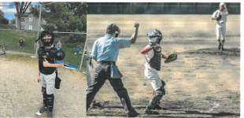
Shoreview Area Youth Baseball (SAYB) is looking for responsible, young adults (age 13 or older by Sept 1) to be umpires for the 2025 SAYB season.
- Games will be played locally on fields located in Shoreview, North Oaks, Vadnais Heights, and Arden Hills.
- Training is provided, both in classroom, and on the field (if requested). Season starts end of April/start of May and runs through end of July.
- There will also be an option to ump fall ball games on Sundays in Sept.
- You get to choose the games you want to do – games are selected by each umpire and there is no commitment for a minimum number of games.
- Sign up for games occurs on a monthly basis, approximately 3 weeks before the beginning of the month.
- Each game is scheduled for two hours. The pay for each game will be in accordance with the following table:
Age | Rec | A | AA | AAA
3rd/4th (8u/9u) | $40 | x | x | x
5th/6th (10u/11u/12u) | $50 | x | x | x
10u | X | $50 | $50 | $50
11u | X | $50 | $60 | $60
There are two dates for registration and training:
Saturday April 5, 10:00-11:15AM, Mounds View High School Room 174
Saturday April 26, 10:00-11:15AM, Mounds View High School Room 174
(Only need to attend one of the sessions)
An optional On-Field Training to be scheduled – recommended for new umpires.
We will also discuss how to become certified to MYAS credentials and ump outside SAYB, if you want to take on that role – purely optional
Spend the summer outdoors enjoying the game of baseball and get paid for it!
Please address any questions to Gary Fariss at gmfariss@yahoo.com or text at 651-324-6785

