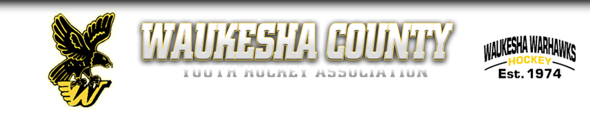
WAUKESHA COUNTY YOUTH HOCKEY ASSOCIATION
MEETING AGENDA-OCTOBER 12TH, 2022
- INTRODUCTIONS
- SEPTEMBER MEETING MINUTES: REVIEW/APPROVE
- SEPTEMBER TREASURER REPORTS
- MEMBERSHIP COMMENT
- NEW BUSINESS
- WAHA Region 5 Meeting Update
- Tryout Recap
- Referee update for 2022-2023
- Scholarship Applications Due by November 4th—via email to Vp Off-Ice
- Wreath Orders are Due by October 23rd—Pick up is November 19th at Eble.
- Knockout Game Purchase.
- Compensated Positions within the WCYHA.
- UPDATES
- PRESIDENT
- VP ON ICE
- VP OFF ICE
- TREASURER
- 14U LEVEL DIRECTOR
- 12U LEVEL DIRECTOR
- 10U LEVEL DIRECTOR
- 6U/8U LEVEL DIRECTOR

Closed Session.

