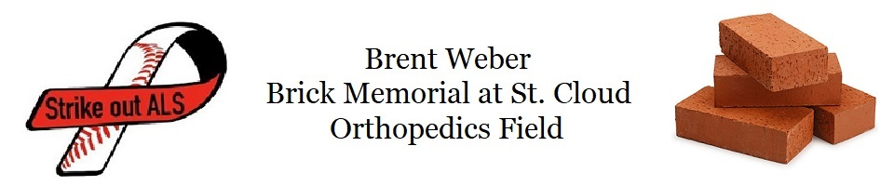
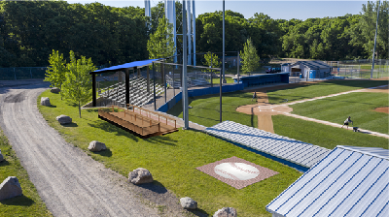
The family of Brent Weber, Sartell Baseball and the Pinecone Park Association would like to announce that a memorial will be installed at St. Cloud Orthopedics Field to honor Brent Weber. There will be a 16-foot brick memorial in the shape of a baseball that will be installed in the grassy area behind the visitors’ dugout. The center of the memorial will include large bricks with an image of Brent and his baseball legacy.
The bricks will be sold for $250 each and the proceeds will be designated towards a capital campaign to enhance the fan seating area. Brent had visions of improvements for Champion Field, now known as St Cloud Orthopedics Field and the sale of the bricks will help to make these enhancements happen.

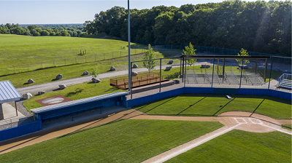
Brent Weber was a pillar in our community and we are fortunate that he shared his passion for baseball with all of us. For 7 years he led the Sartell Baseball Association through significant field improvement projects, programming expansion and player growth. He served many roles in our league from cooking burgers at tournaments, working on the fields, coaching, and serving as our President. The Sartell Baseball Association contributes much of our success over the past decade to his dedicated service and leadership. Brent’s impact made a significant difference that will be felt in the Sartell area baseball community for many years to come. Brent showed a courageous battle with ALS and it’s an honor to recognize what he meant to all of us and to leave a legacy at this ballpark in his name.

Donor Information  Name: _____________________________________  Address: _____________________________________  City, State: _________________ Zip code: __________  Email Address: ________________________________  Phone Number: (___)____________________________  Clip Art # ____________________________________  Replica Tile $20 Y/N  Donation Amount: $ ____________________________  Please Make Checks Payable To:  PineCone Park Association  Mail To:  P.O. Box 2  Sartell, MN 56377  Clip Art Selection  A02 A06 A12 F03 F04  F05 F13 K01 K05 K31  P11 P15 P23 P37 P42 | Brick Information  4” x 8” engraved brick $250.00 with Clip Art or Logo $260.00  If ordering a brick with clip art please do not write in shaded areas.  To order online and for more clip art choices please visit: www.polarengraving.com/ pineconeparkassociation

