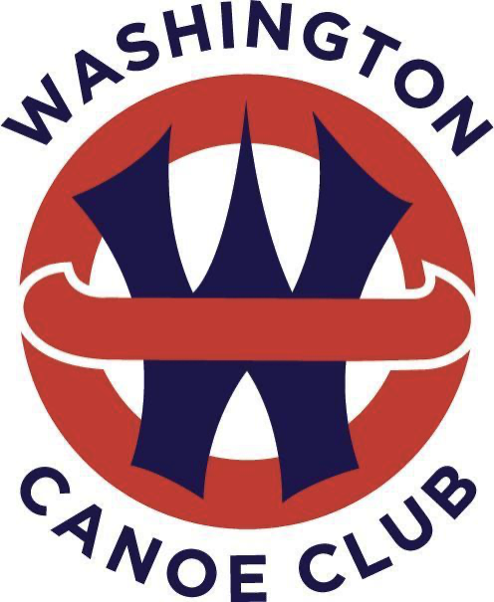 Boathouse Restoration Campaign Gift Form

Thank you for your commitment to the Washington Canoe Club Boathouse Restoration Campaign.

Please accept my gift to the Washington Canoe Club at the following level:
- $______________________________________________

Payment schedule
I will fulfill my commitment to the Washington Canoe Club as follows:
- $___________________________ one-time payment by ____________________ (date)
OR
- $___________________________ installment by _____________________ (date)
- $___________________________ installment by _____________________ (date)
- $___________________________ installment by _____________________ (date)

Payment Method (Please check one)
- I will mail a check made payable to the Washington Canoe Club | PO Box 25449 | Washington, DC 20027
- I will donate online https://www.washingtoncanoeclub.org/donate
- I will donate by stock (form and instructions below) https://www.washingtoncanoeclub.org/donate

Name ________________________________________________________________________
Address________________________________________ City _______________ State _______
Email_______________________________________________ Phone____________________

Gift Recognition
Please recognize my gift in contributor listings as follows (please indicate if you wish to remain anonymous)
______________________________________________________________________________

I agree that the Washington Canoe Club may publicly refer to this gift prior to its delivery,
as a gift promised by me/us and that the Washington Canoe Club may act in reliance on this
gift/pledge.
Signature:___________________________________________ Date:_____________________
The Friends of the Washington Canoe Club (EIN #02-0606647) is a 501(c)3, tax exempt organization.
Questions? Please contact:
Melissa Groth Miller, WCC Campaign Assistant
fundraising@washingtoncanoeclub.org

