Minnesota Hockey Patient Encounter
We are trying to track the work to show importance of having medics at our tournaments.
Please give to your medics and have them fill out the sheet.

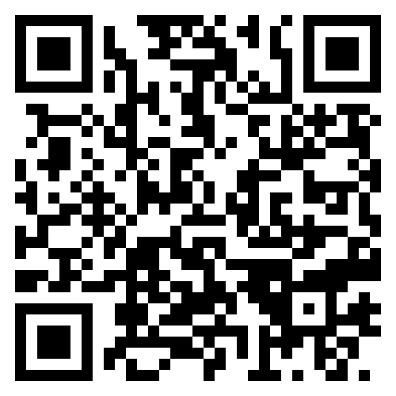
If you have any questions, call:
Mike Mannin
USA Hockey, MN Player Safety Coordinator
763-807-2678

