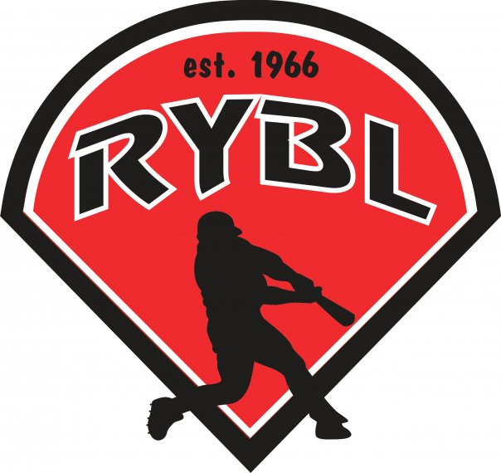
RYBL October 2022
Board Meeting
10/27/2022 7:30 PM
- Call to Order 7:33 PM
- Opening Prayer
- Pay Greg for expenses and mowing.
- Previous Board Minutes Approval – Andy Keogh
  - September 2022 Minutes – Approval
- Treasurer’s Report – Adam Brock - VACANT
  - Current Bank Balance: $31,942.60
    - Outstanding Bills: $4083.69 CHECK FOR GREG FOR MOWING
    - Accounts Receivable: SPONSERHIPS AND CONSESSIONS?
- Office and Committee Reports
- Secretary – Andy Keogh
- President – Bryan Altmaier
- 1st Vice President- Chris Pavey JJ PULLED ALL OF POLES OUT OF NORTHSIDE CITY OF KOKOMO IS DONATIONG TO US FOR FREE, THEY NEED TO TEST THEM – WE WILL TAKE THEM – HE WANTS TO SIT DOWN WITH US TO TALK ABOUT COST – BY LAWS NEED TO BE VOTED ON NEXT MEETING WE WILL VOTE ON AS SOON AS POSSIBLE -
- 2nd Vice President – Mickey White OLD SIGNS GET THROWN AWAY IS GOOD – GO THROUGH THE EQUIPMENT ROOM AND ORGAINIZE – SHED HAS TRASH IN IT – LOW SEAM MACHINE BASEBALLS NEED REORDERED -
- Player Agent – Vacant NEXT SEASON - ZOOM MEETING
- Equipment Manager – Dawn Hyman BASEBALLS BUYING – FINDING A NEW LOGO SPONSER TEAM – BASES – CUT OFF SAFETY BAG
- Umpire in Chief – Matt Adams – FINDING OUT DANS FEES FOR FALL – DO WE NEED AN UMPIRE FOR FALL BALL – UMPIRING IS ON THE RISE WITH LESS SHORTAGE – UMPIRES HAVE A DAY OR A FLOAT –
- Unfinished Business
Closing Field Day, I will be out there Saturday Oct 29th at 10:30am to shut water off and take down signs. Should be simple, shutting water off, getting hoses all put away. I say we keep the nets up and look at replacing some of them in the spring. We can look at backstop options in spring. SIGNS ARE DOWN ALREADY/ POSSIBLE VANDALIS – Take THE BACK STOP DOWN FOR THE WINTER – THERE IS EXTRA WIND SCREEN IN THE EQUPMENT ROOM?
- New Business
Voting in new members: We usually only have 4 at a time but with player agent stepping down we will vote in 5 this time with player agent being a one-year term. WE NEED CAMERAS – FLAG ROPE NEEDS REPLACED - APRIL 29TH OPENING DAY
President - 2YR - BYRAN ALTMAIER HAS ACCEPTED
Treasurer - 2YR - DJ BUTCHER HAS ACCEPTED
Player Agent - 1YR - BRANDON DARLING HAS ACCEPTED
2nd Vice President - 2YR - MICKEY WHITE HAS ACCEPTED
Umpire in Chief - 2YR - MATT Adams has accepted
Secretary - 2YR
SOCIAL MEDIA – 2YR - TAYLOR WHITE HAS ACCEPTED
- Adjournment – Next board meeting is Thursday Nov 17th, in our by laws it says we skip December? We haven’t in the past and I think I would rather skip November then December but will leave up to the group.

