The 2025 Porter Parent Football Association (PPFA) Newsletter – Week9
The LTHS Porter Parent Football Association (PPFA) is a volunteer group dedicated to enhancing the football experience for players. Our goal is to foster a positive, memorable environment for each player, achieved through support for both the players and coaches. The PPFA funds its efforts through various fundraising initiatives, including spirit wear, player sponsorships, and volunteering.
- Twitter @LockportFootba1 - Facebook @ LTHSFootballBoosters  - Lockportfootball.com
Every Week
Varsity Players Pasta Dinner – Every Thursday @ Cooms Corner.
Week9 Pasta Dinner (Cooms Corner): 10/23 @ 4:30pm **Parent Volunteer and/or Dessert Donation**
** Ask-a-Porter ** - 10Q with Mason Moore
Game Schedule/Results
Varsity: Porters @ Neuqua Valley: Fri 10/24 @ 7:00pm Game Preview
Porters over Metea Valley on 10/17 (34-21) Game Recap
Sophomore: Porters @ Neuqua Valley: Fri 10/24 @ 4:30pm Porters lose to Evanston on 10/18 (x-x)
Freshman A: Porters @ Neuqua Valley: Thu 10/23 @ 5:00pm Porters A over Metea Valley on 10/17 (x-x)
Freshman B: Porters @ Fenwick: Sat 10/25 @ 9:30am Porters B lose to Oak Park on 10/18 (x-xx)
News and Notes
PPFA ave-the-Date: 10/31 - State Playoffs (first round)
**Lost and Found** Missing a PPFA 2025 Newsletter? Click HERE

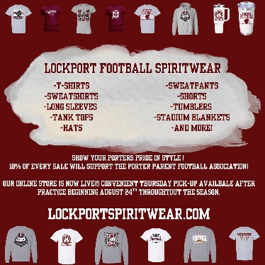
Order your 2025 Lockport Football Spirit wear HERE
Helpful Links
Spirit Wear Game Digital Tickets IHSA Football Info 8to18

