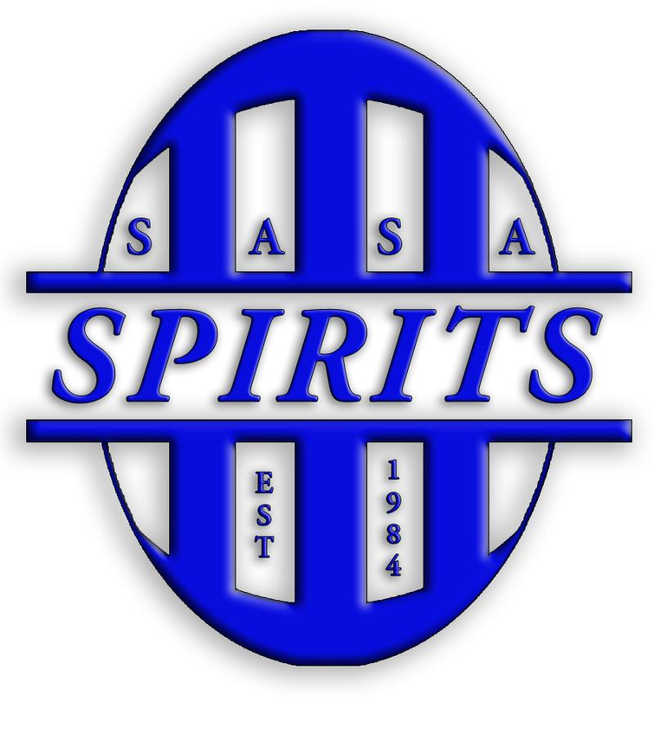  SASA SPIRITS SOCCER Program  Spirits soccer is back in action—training for another successful season! You can be a part of an exciting 2018 Spirits Season through your participation in our first ever soccer Program. Through your business or personal ad, you can support the club throughout the year.  Ad Rates:   Full-Page ($50) No Bleed 7.5 x 10 inches   Half-Page ($25) Horizontal 7.5 x 4.875 inches   Quarter-Page ($15) 3.625 x 4.875   Fee for Capitol Blueprint to design ad ($10)  Payment must accompany the form. Make checks payable to SASA.  Company Name _______________________________________  Contact Name ________________________________________  Address _____________________________________________  E-Mail Address ________________________________________  Phone Number ________________________________________  Programs will be available by Region II  Thank You | Support SASA Soccer.  ────  Multiple Ad Sizes. Design your own or let Capitol Blueprint make it for you.  Deadline:  August 25th  E-mail ad copy (PDF file) to: Heidi Daly Heidi.daly09@gmail.com by August 25th  Mail the completed form and check payable to SASA to:  SASA  PO Box 904  Springfield Il 62705  ────  Company Name  Street Address  City, ST ZIP Code  Telephone  Web Address  Dates and Times

