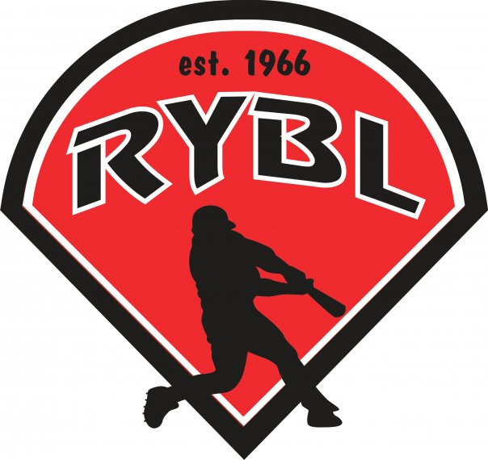
RYBL August 2022
Board Meeting
08/24/2022 7:30 PM
- Call to Order
- Opening Prayer
- Previous Board Minutes Approval – Andy Keogh
  - June 2022 Minutes – Approval
- Treasurer’s Report – Adam Brock
  - Current Bank Balance: $ 35,421
    - Outstanding Bills:
    - Accounts Receivable:
- Office and Committee Reports
- Secretary – Andy Keogh
- President – Bryan Altmaier internet turned on
- 1st Vice President- Chris Pavey – phone tag with j and j we have a trench guy that needs help
- 2nd Vice President – Mickey White
- Player Agent – Vacant leads tryouts – puts players on teams and setups drafts – deals with late kids – follow draft matrix and balance league the best for league
- Equipment Manager – Dawn Hyman – excused
- Umpire in Chief – Matt Adams - sick
- Unfinished Business
Fall Ball Update? Almost 160 players registered this year. That was increase from 151 last year.
J&J hoping to get the poles and aluminum wiring fixed after fall ball. We should have enough after fall ball profits and concessions to finish this job at least the major league field. Motion made for two-wheel line caulker – passed
Wind screens tabled until spring
- New Business
Adding a new board position- Social Media Manager/Sponsorship Manager to be voted on in October supported as a board position waiting on two thirds vote. Passed
- Job duties would include running online platforms for the league, sending invoices out to sponsors, and actively trying to get more sponsors into the league. Responsible for sponsor shout outs, league information, game highlights, etc.
Filling Adam Brock and Zac Resers spots. Is anyone else not planning to come back next season? We need to know so we can plan to fill these spots in October.
Closing Field Day (October 1st and 8th) Should be really simple, shutting water off, getting hoses all put away. I say we keep the nets up and look at replacing some of them in the spring, We can look at backstop nets and see what condition they are in to see about needing replaced or take down and reuse for next season.
*Field Material replenishing costs
Leffert Stone $95 to deliver to Russiaville 2 pallets of material
Play ball Conditioner $12.45/bag x 40 bags= $498
Drying Agent $9.95/bag x40 bags = $398
Total $991 for field material
- Burlington Park maintain at least 3 fields about 10 min away, I want to talk to their park board about getting practices scheduled out there next spring and see about using their barn for winter practices as well. They have two cages and a big open area for fielding. I think it would be a great addition to our fieldhouse/Bullpen practices we schedule for teams. This can also be used during the season for practices and we might be able to use fields for overflow on games during the season. We might need to see about a mobile concession stand or even a food truck to come out for a couple hours for the games? I would like to see about costs and if maybe we can do some interleague games against NW out there as well.
Talking with John Conn about the logistics and costs associated with this. Any input? Good idea

Ideas on how many games we want to play out there?
Next project after lights? Any ideas? Enclosed batting cage and turn t-ball field into major field – frank can do a grant writing for a new field – cut out base paths?
Fundraising ideas for next season? Dunk tank
- Next board meeting is Thursday Sept 15th at 7pm
- Adjournment

