
East Lincoln Optimist Club
Soccer U5 and U6 Playing Rules
This league is designed to instruct players on the basics of soccer. There is a zero tolerance policy for poor sportsmanship from coaches, participants, and parents. Coaches and parents are to remember that these games are for the kids – not the adults.

Law 1
The Field of Play:
Dimensions:
The field of play must be rectangular. The length of the touch line must be greater than the length of the goal line. Length: maximum 30 yards Width: maximum 20 yards
Field Markings:
The field of play is divided into two halves by a halfway line. The center mark is indicated at the midpoint of the halfway line and will be marked by a circle around it. A goal area will also be marked to assist in locating the ball for goal kicks.
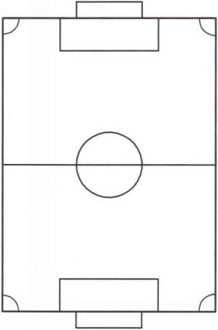
Touch Line

Halfway

Line

Center

Circle

Goal

Area

Goal

Line

.

Center

Mark

Goals:
Goals must be placed on the center of each goal line. .
Law 2
The Ball: Size three (3).

Law 3
The Number of Players: A match is played by two coed teams, each consisting of four (4) field players, no goalies. No goalies at this age helps eliminate any confusion with the “no hands” rule in soccer.
Substitutions:
At any stoppage of play/unlimited or whenever necessary (player leaves field in midst of play).
Playing time:
Each player SHALL play a minimum of 50% of the total playing time.

Page 1

Law 4
The Players’ Equipment: Players will be provided uniforms for games. Players must wear shin guards at all times, practice or game time. Cleats are not required for U6 but encouraged for traction as field conditions tend to be wet.

Law 5
On-field Coaching: This is a teaching league. Coaches from each team are allowed on the field of play at all times to instruct player movement. Coaches are encouraged to “cheer” for both teams and acknowledge play of players of all teams.

Law 6
The Duration of the Match: The match will be divided into four (4) equal quarters of eight (8) minutes each with one (1) minute between quarters. There will be a five (5) minute halftime. Time is to be kept by coaches. The length of quarters can be adjusted and agreed upon as coaches see fit. The clock does not stop except for injuries or for equipment issues (for example, the goal gets dislodged).

Law 7
The Start and Restart of Play: Teams will alternate kick-offs each quarter. Opposing players should stay outside of the center circle until the ball is touched or played. Player taking the kick should wait for a whistle (if available) and pass the ball to a teammate and not dribble down field. Out of courtesy, it’s good sportsmanship to wait for both teams to be ready to play whenever play is stopped / restarted.

Law 8
The Method of Scoring: A goal is scored when either team shoots the ball and it crosses the goal line completely. The ball should be taken to the center mark for a kick-off by the non-scoring team.

Law 9
Fouls and Misconduct: Play should only be stopped for blatant fouls (pushing, tripping, or picking up ball) or repetitive dangerous play (slide tackling). Most corrections/coaching will be done during the game to allow play to flow as much as possible.

Law 10
Free Kicks: If play is stopped for a blatant foul or dangerous play, the opposing team will be awarded a free kick from the spot of the foul. Ensure opponents are an ample distance from the ball when the kick is taken.

Law 11
The Throw-In: Throw-ins will be awarded to the opposing team when the ball is kicked over the touch lines. Proper technique should be taught/practiced with emphasis on throwing ball overhead (arms starting behind head).

Law 12
The Goal Kick: A goal kick will be awarded when the opposing team kicks the ball over the end line. The ball should be placed within the goal area for kicking and opposing players should be kept a reasonable distance from the ball to allow play.

Law 13
The Corner Kick: A corner kick will be awarded when the defending team kicks the ball over their goal line. The ball should be placed at the corner on the half of the field the ball went out on. Opposing players should be kept a reasonable distance from the ball to allow play.

Page 2

