The 2025 Porter Parent Football Association (PPFA) Newsletter – Week1
The LTHS Porter Parent Football Association (PPFA) is a volunteer group dedicated to enhancing the football experience for players. Our goal is to foster a positive, memorable environment for each player, achieved through support for both the players and coaches. The PPFA funds its efforts through various fundraising initiatives, including spirit wear, player sponsorships, and volunteering.
- Twitter @LockportFootba1 - Facebook @ LTHSFootballBoosters  - Lockportfootball.com
Every Week
Varsity Player Pasta Dinner – Every Thursday @ Cooms Corner
Note - Varsity players will be provided weekly dinners the night before every game.
Week1 Pasta Dinner: 8/28 @ 4:30pm **Parent Volunteer and/or Dessert Donation**
** Ask-a-Porter ** - 10Q with Brendan Mecher
Game Schedule/Results
Varsity: Porters vs Plainfield North: Fri 8/29 @ 6:15pm Varsity Football Preview Game Preview
Sophomore: Porters vs Plainfield North: Sat 8/30 @ 9:00am Sophomore Football Preview
Freshmen A: Porters @ Plainfield North: Sat 8/30 @ 8:30am Freshmen Football Preview
Freshman B: Porters @ Plainfield North: Sat 8/30 @ 10:00am
News and Notes
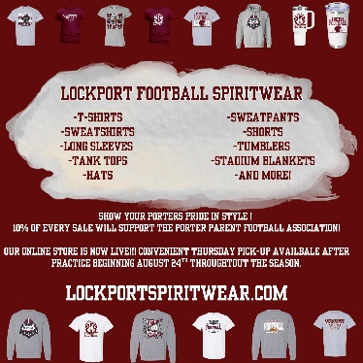
Order your 2025 Lockport Football Spirit wear HERE
PPFA Board Meeting: 9/16 (Tuesday) @ 7:00pm – LTHS (Porter Room)
Save-the-Date: 9/5-Senior Night 10/3-Homecoming 10/31-State Playoffs (first round)
Helpful Links
Spirit Wear Game Digital Tickets IHSA Football Info 8to18

