US LACROSSE MEMBERSHIP GUIDE
How to get a US Lacrosse Membership (first time players)—US Lacrosse Memberships are required by the school and for our program’s insurance. Your membership must be renewed every year that you play and must be valid for the entirety of the season.

https://membership.uslacrosse.org/
Go to the membership page of US Lacrosse. The page should look like the screen shot below.

Click the button that reads “CLICK HERE TO START”
This will open the log in/ register page as seen below. Click “CREATE MY ACCOUNT”

The form seen below should come up, fill in the information accordingly

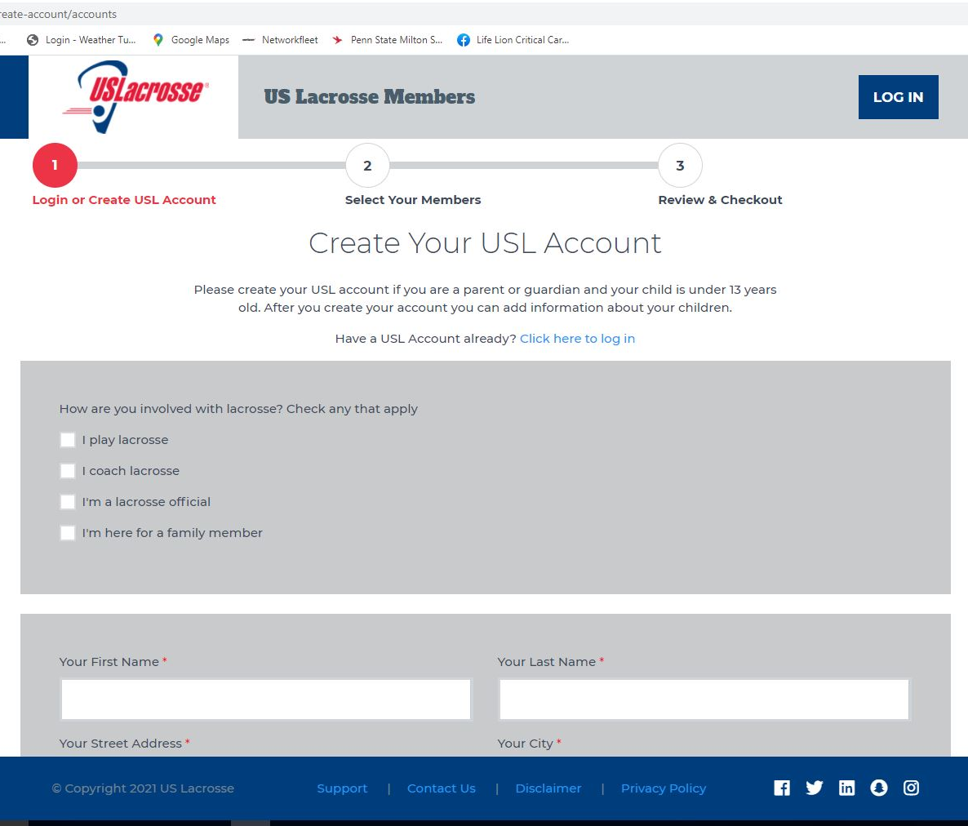

The program needs both the US Lacrosse membership number for your player as well as the expiration date. (Both of these items will be given when membership is created)

How to renew your US Lacrosse Membership (returning players)—US Lacrosse Memberships are required by the school and for our program’s insurance. Your membership must be renewed every year that you play and must be valid for the entirety of the season.
https://www.uslacrosse.org/
Go to the main page for US Lacrosse
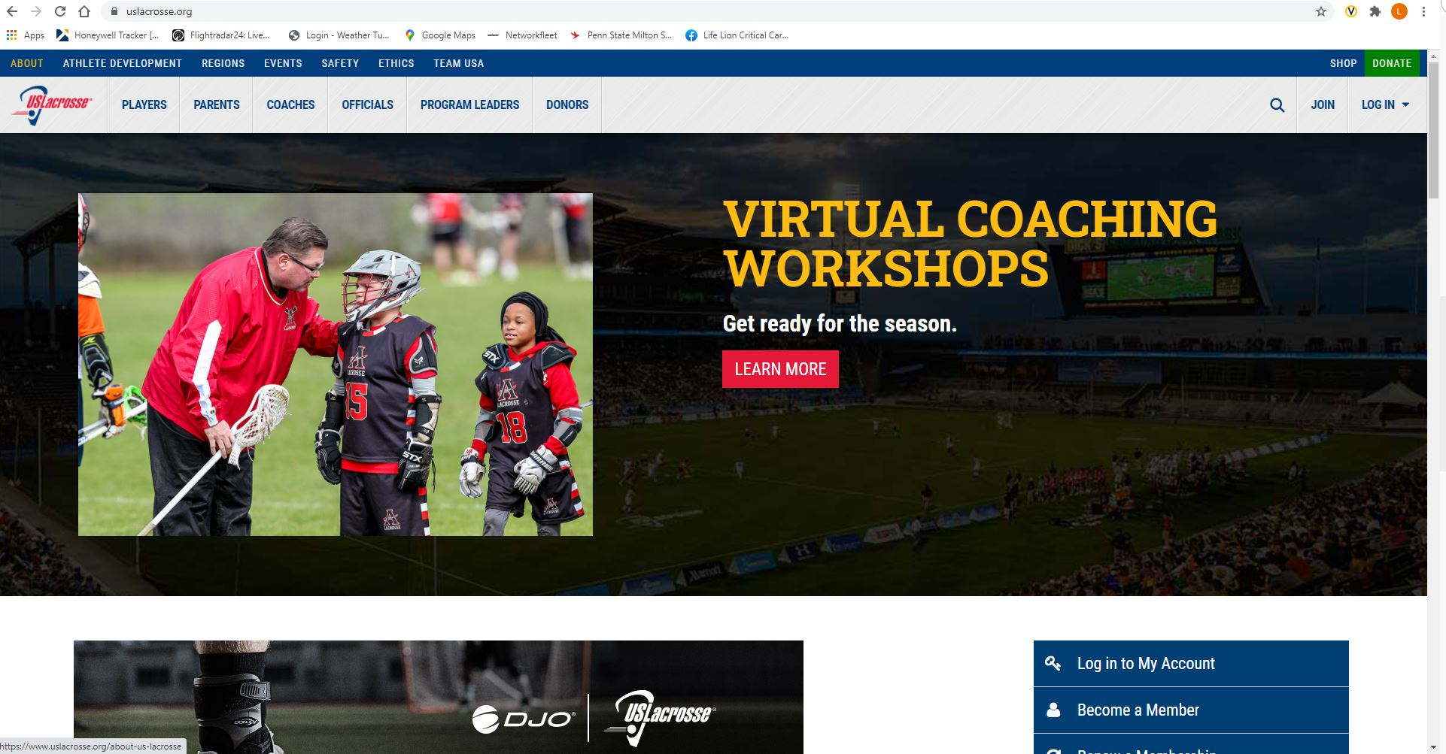

Hover over the word “PLAYERS” and choose “Renew Membership” from the dropdown.

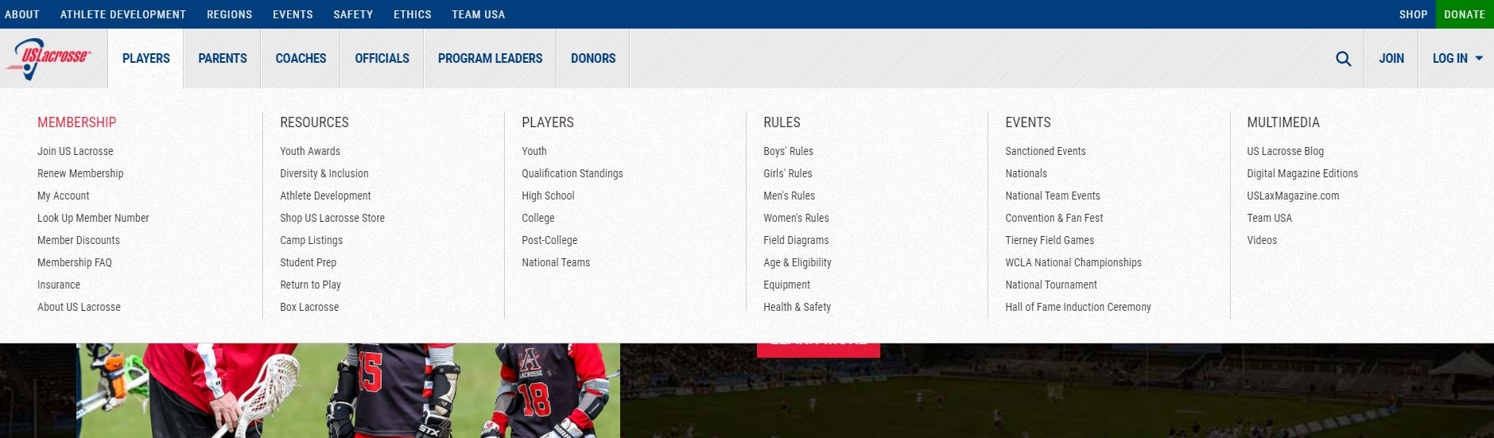

Click the button that reads “CLICK HERE TO START”

This will open the login page where you enter your credentials to get into your account.

It will then bring up the page shown below where everyone in your family will be visible- showing their names, us lax numbers, expiration dates, and the ability to check a box that reads “NEEDS MEMBERSHIP”. Check that box for all memberships that need to be renewed.
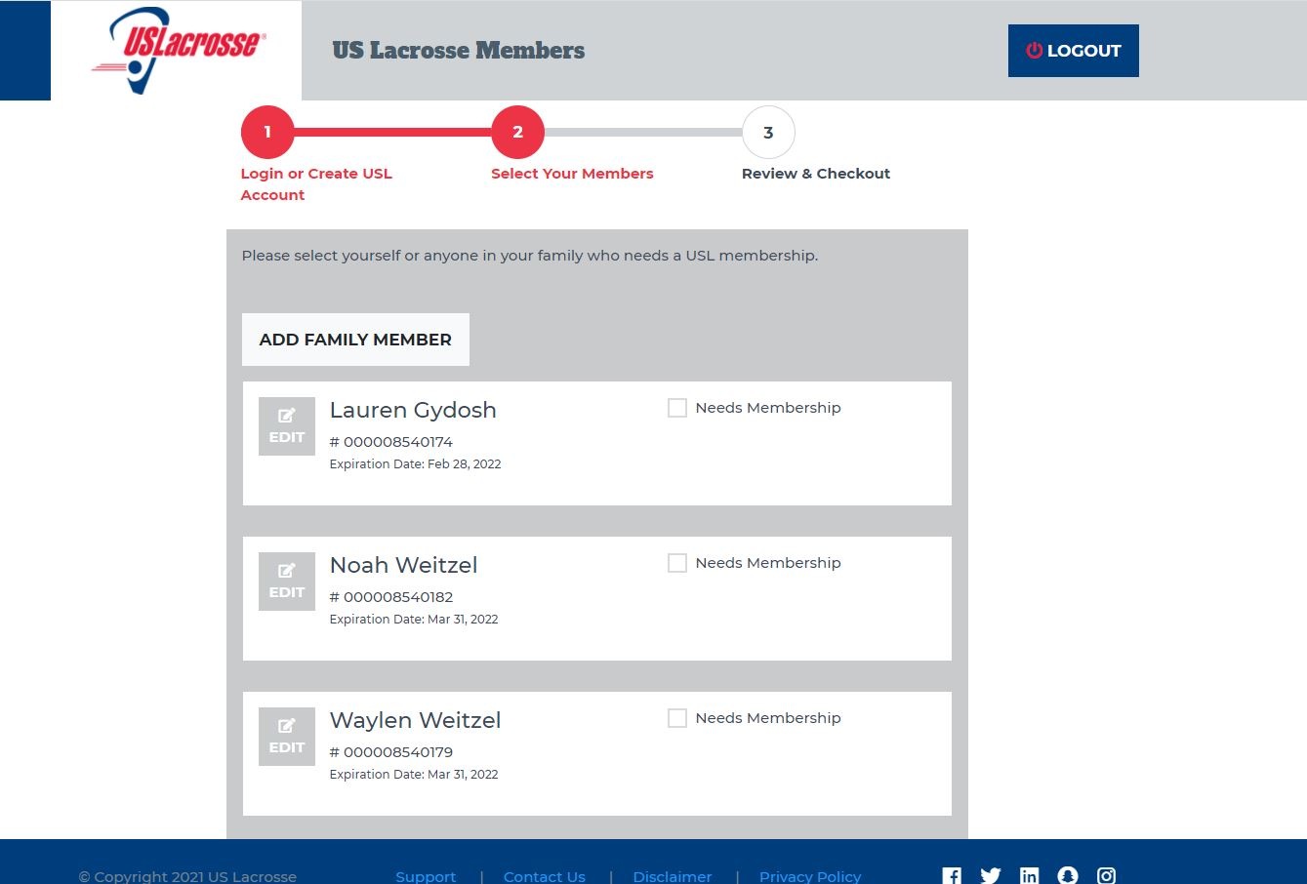

The next page will be where you enter your payment information to complete the renewal.

The program needs both the US Lacrosse membership number for your player as well as the expiration date. (Both of these items will be given when membership is renewed)

