- Visit mvaathletics.campbrainregistration.com

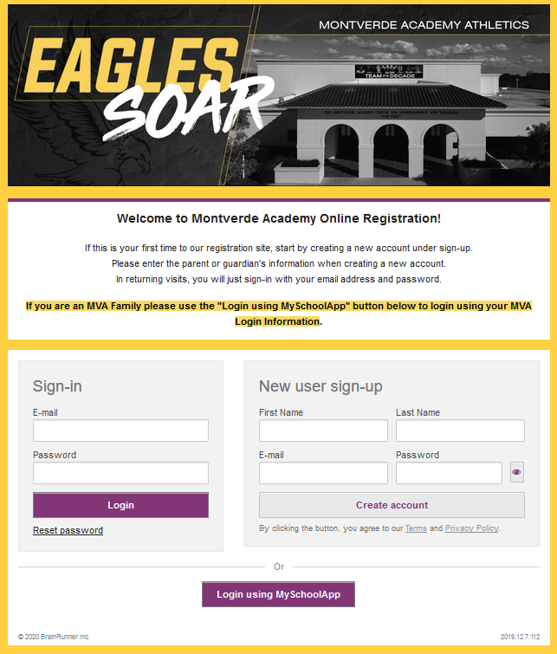
MVA Students
Non-MVA students
- If your child is an MVA student, click on “Login using MySchoolApp”
- If your child does not attend MVA, go to “New user sign-up”

- Once you are logged in, you should see a screen similar to the below with the option of “SIMA Winter Camp” . Select the program you want to register for by clicking “Start application”

- Follow the on-screen instructions.

- Registration will be confirmed with an email to you.

