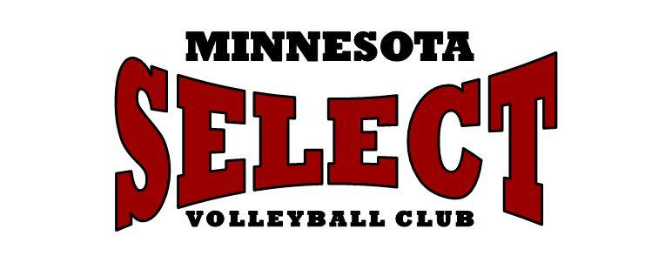
2020 VolleyTots & Youth Academy Winter Session II
Wednesday, February 19th – Thursday, March 26, 2020 ⁽six weeks)
GOAL: Volleyball playground designed to expose youth to the sport of volleyball through instruction in hand-eye coordination, volleyball specific movements, and basic skills of the sport (passing, setting, hitting, & serving). Teaching motor learning and skills development using fun activities! Both boys and girls are welcome!
LOCATION: MN Select Volleyball Center – 8686 Valley Forge Lane, Maple Grove, MN
Weekly Schedule:
Wednesdays: | 5-6:25pm | Grades: 3rd-6th | $40/Class
 | 5-5:55pm | Grades: PreK-2nd (Ages 4-8)* | $30/Class
 | 6-6:55pm  6:25-6:55pm (after 3rd-6th grade class above) | Serving Class (3rd-8th graders)** | $30/Class  $15/Class

Thursdays: | 5:30-6:25pm | Grades: 2nd-4th | $30/Class
 | 6:30-7:25pm | Grades 5th-7th | $30/Class

* The court will be divided in half by mini-nets. Younger players will be on one side (Pre-K) while older players (1st-2nd graders) will be on the other side.
** Serving is an individual skill. We can work with a wide variety of age/experience levels at once due to the individual nature of serving.
Series Discount – attend the same class, one night a week, for six weeks:
- $155/session for six classes normally $30/class (55-min classes)
- $210/session for six classes normally $40/class (85-min class)
- $300/session for six weeks of 85-min class plus 30-min of serving class
Register Here:
Individual classes can be purchased online by date for the prices listed above. Walk ups are welcome, but we suggest emailing info@mnselect.com before coming in to check if the class is still on.
Any questions? Email us at info@mnselect.com. We’re here to help!

