SAC - MT
Meeting Minutes
11/16/2023

Call to Order: Josh Burnham (SACC) called to order the regular meeting of the SAC-MT at 11:00 a.m. via Google Meeting. Present members: Josh Burnham, Denis Berry, Crystal Lawrence, and Sharon Mozer.

Announcements:
- Financials - $37,654.07

2. Motion moved to approve minutes from 10/11/23.
Motion: Denis Berry
Second: Crystal Lawrence
PASSED

Old Business:
1. State Cup - Meet host BGS January 5-7, 2024
- Schedule changes due to Level 2 entries. This will impact the session start time. Will close meet registration as it is full.
- Proposed schedule:
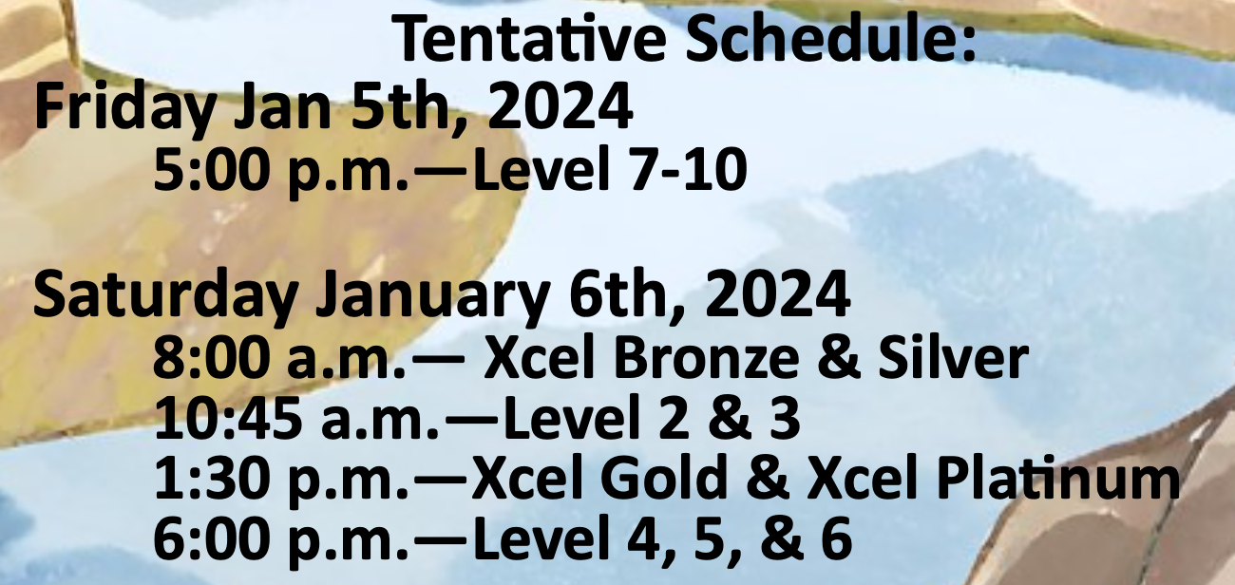

- Board responsible for cost of awards.
  - Split age group for awards
  - Ribbons for Bronze/Silver and Levels 2-5. Since Level 5 is in the same session as Level 4, ribbons will be awarded for both Levels 4 and 5.
  - Medals for all participants.
- Per R&P - pg 28 (Medical Personnel/Procedures )
  - Josh to contact Sandy Flores (R2RACC) to discuss options, in case the Meet Director is unable to secure the appropriate medical personnel, due lack of availability.
- Additional costs to consider and possible shared expenses with the host are chair rentals and medical personnel.

2. Leotard state fundraiser for pre-season for the Fall of 2023
- Ozone company
- Profit breakdown - If we sell 100 leotards for $50 each, the profit will be $31.00 for each leotard sold. If we sell 50-99 leotards, the profit will be $26.05 for each leotard sold.
- As of date, 16 leotards have been sold (2 days of kick-off).
- Will need to send a few reminder emails with a link to purchase leotards. The fundraising drive will conclude December 1st.

New Business:
1. Social Media - Board will establish a FB and Instagram account for Montana Gymnastics. Members will be extended to coaches, club owners, and judges. All board members will be the administrators.

2. State Handbook - Board will start developing the MT state board handbook at the next board meeting (December).

3. Montana Summer Camp 2024
- Discussed sponsoring the Dan Alch camp, repeating what Montana provided 2 years ago Vs developing a camp by the board. Josh will confirm the cost of Dan Alch’s camp per athlete.
- Montana State Camp considerations:
  - Need to secure date (June/July/August)
  - Find a host gym
  - Dan Alch Camp available dates: June 13-15, July 5-7 or 19-21, August is open
  - Board to find clinicians

4. State Championships - Hosted by HAC March 22-24, 2024
- Laura Snellman (Meet Dir) would like to implement the same meet format/schedule as last year’s 2023 State Championships.

Other:
1. Motion moved to have the Xcel Divisions Gold, Platinum, Diamond, and Sapphire to require a 2-judge panel for state qualifiers.
Motion: Sharon Mozer
Second: Crystal Lawrence
PASSED

2. Motion moved to indicate that in order for any Xcel athletes to qualify to the State Championships, they must have competed in a sanctioned event, with a minimum of a dual meet (2-clubs) setting.
Motion: Denis Berry
Second: Crystal Lawrence
PASSED

3. “At a Glance” will be posted once the information is updated.

Adjournment: Motion to adjourn at 11:39 a.m.
Motion: Sharon Mozer
Second: Denis Berry
PASSED
Next Meeting: 12/14/2023 at 10 a.m.
Minutes submitted by Sharon Mozer

