TRIPLEBALL

Overview of the Tripleball Sequence:

a) The game follows a sequence of three rallies (service, tossed ball 1, tossed ball 2).
* 1st Rally – Introduced by the server
* 2nd Rally – Freeball tossed to the receiving team
* 3rd Rally – Freeball tossed to the serving team
b) The service rotates between teams after each three-ball sequence
c) A team must rotate and introduce a new server when it is their turn to serve.
d) Every ball introduced is worth one point.

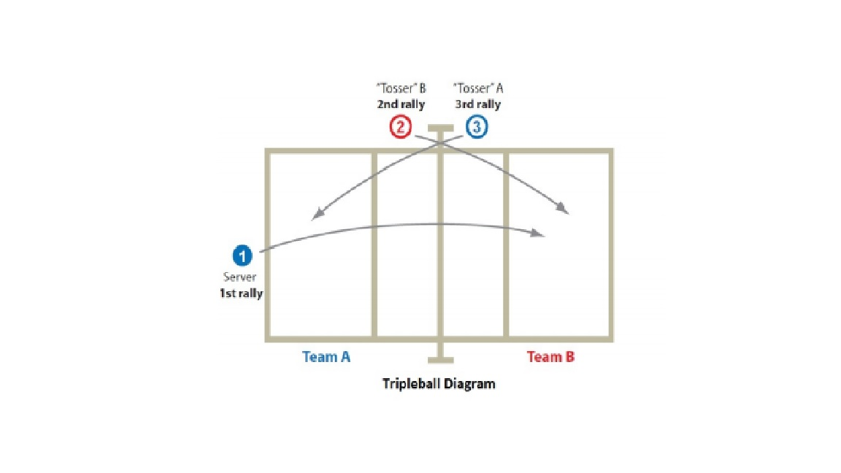
Tripleball Rules:

A) Switching to a different position from your service order during a rally is NOT ALLOWED.

B) Each rotation will have a different designated setter.

C) The coach must write his full service order on the score-sheet, including the athletes on the bench in the proper order in which they will enter the game. After the three-ball sequence, players on the serving team will rotate clockwise. Player in 1 who just served will go to the bench and the incoming player will go to position 6.
D) The services order will be carried over from the end of a set to the start of the next set. The same order will be rolled over and played throughout the entire match.

Toss:

A coach, assistant coach or a competent volunteer can toss the free ball to their team and can step into the court to do so from across the net. The tosser will immediately move off the court after the toss.

Free balls are tossed underhand, with two hands and little to no spin, above the height of the antennae to allow athletes time to play the ball.

The free ball will always be tossed directly to the athlete in position six (6), otherwise a replay will occur.

Athletes can only play tossed free balls from behind the attack line, otherwise a replay will occur.

The free ball will be tossed once the front row players are at the net (ready to transition) and all athletes have been verbally told that the ball is being introduced, “Free Ball!”.

The ball can be sent over the net on first contact, however the intent of having a tosser is to make pass, set, spike rallies easier to achieve.

Time Outs

Requests for time-outs during the three-ball sequence will be considered improper requests; time-outs must be made before the introduction of a serve.

Ball Retrievers

Please make sure each tosser has a ball ready to toss before the 1st ball (serve). It is the team’s responsibility to shag balls before the 3 point sequence begins.

