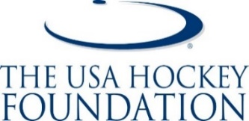

HOCKEY HISPANA FUND
The USA Hockey Foundation is proud to help facilitate the Hockey Hispana Fund to provide grant awards to 8U and 10U female hockey players who are registered with USA Hockey associations in Colorado. The fund was created in 2021 in order to make the sport of hockey more inclusive for Latina youth hockey players.

Grant awards for this fund will be used for individual players registration fees through their hockey association and the player will receive some funding for equipment through Pure Hockey. Grant awards will be paid directly to the hockey association and not to the individual receiving the grant award.

Please note that individuals applying for this grant must be registered with USA Hockey. A copy of your hockey bill and most recent copy of your tax return must be included with the grant application. The deadline to apply each year is June 1st. Please email the completed grant application to:

The USA Hockey Foundation
Attn: Sheila May, Director of Donor Relations
1775 Bob Johnson Drive
Colorado Springs, CO 80906
(719) 538-1107
Email: sheilam@usahockey.org

Player Name: __________________________________________________________________
Player Date of Birth: ____________________________________________________________
Team Name: __________________________________________________________________
Hockey Association: ____________________________________________________________
Parents/Guardian Name: _________________________________________________________
Address: ______________________________________________________________________
City: _______________________________ State: _________________ Zip: _______________
Phone: _______________________________________________________________________
Email Address: _________________________________________________________________

Please ask your child to write a few sentences on another piece of paper on why they are interested in the playing the sport of hockey and how this grant will make an impact.

