
Boys Hockey Booster Club
February 12th 2025

Board Members:
Keith Bridgeman President | Allison Fuller Vice-President | Brian Soucy Treasurer  In Training | Jason Conway Treasurer
Shavon Anderson Secretary | Dave May Head Coach ABSENT | Jennifer Miller At-Large | Dave Bennett At-Large ABSENT
Dave Rodgers At-Large | Brad Farrell At-Large | David Marsh At-Large ABSENT | Gavin Bade Volunteer
Mike Budde At-Large ABSENT | Joleen Budde Volunteer | Rob Donahue At-Large | Stacey Farrell At-Large ABSENT
Tom Whirley | Ryan Harrison | Todd Gyilling

CALLED TO ORDER: 0713am

Coach’s Updates:
(Dave May)
Treasurer Update: CASH from hockey fights cancer $500, $2500 donation from FYHA – should be back to around normal end of year balance
T90 filings, Brian reach out to accountant for audit - April (Bennet Company)
(Brian Soucy, Jason Conway) 49,821 + $3,000 approx bal

Remaining payments due – couple misc receipts coming in
- Brackets Crossing
- Benny Lego
- TPE app to record/live feed

Tiger Fan Club liaison / 501-C3: approved
(Keith Bridgeman, Brad Farrell, Allison Fuller)
- Completion of ISD 192 Booster Club registration once application is finalized. This is stuck with the IRS as they are behind in processing.

Apparel Coordinator:
(David Bennett, Brian Soucy)

- Sale of remaining apparel. Choose date. Banquet – cash/check
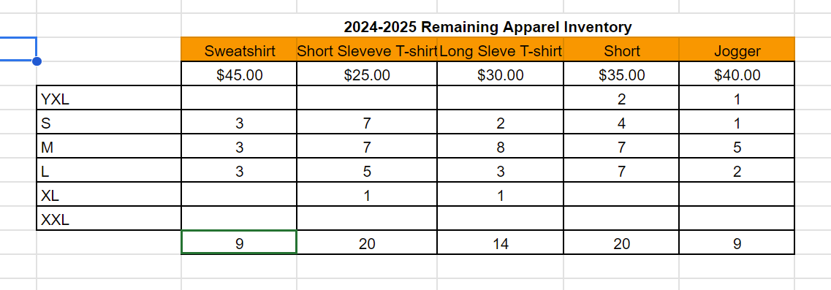

FHS Girls’ Program Liaison: (Allison Fuller)

Team Building/Community Outreach Coordinator/FYHA Liaison:
(Shavon, Allison, Jen, Joleen)

- Charity / Team building event. Senior home Bingo still getting info from Dave M
Fundraising Coordinators possible need for more fundraising (maybe Gertens in the fall) to offset the increased expense for registration
(David Rodgers / Mike Budde)

Sponsorship Drive / Jersey Sponsorships
(Dave Marsh)
- Sponsor drive update.
Game Day Production / Rink
(Keith)
- Nothing new JUST need to continue to build it up

Game Day Programs Coordinator contact Dave M about left overs and see what families don’t have one and get them to them at the banquet
(David Marsh, Stacy Farrell)
- Complete

Photography Coordinator will continue to come to additional section games
(Keith Bridgeman, Stacy Farrell)
- Game photos that Benny will be at to take pictures.
  - Feb 20th Sections

Senior Night Coordinators
Allison, Katie, Joleen
- Complete

Social Media/Webmaster/Communications Coordinator: Megans on it – maybe see if Lucy (manager) is interested or another student
(Keith Bridgeman)
- Transition Social Media game updates to Megan Grant. She has access now to X, Instagram and Facebook. Will get her access to Gipper next.
Team Meal/Snack Coordinator: ordered pizzas for Friday for JV/VAR – reach out if interested in hosting
(Jason / Allison)
- Team meals at peoples’ houses or FHS.
  - Team meal the week of sections? Check local options
- Subway, Noodles, Culver’s, Chick Fil-A have been used for out-of-town games.

Alumni Liaison/Legacy Fund:
(Jen Miller)
- College Photo Wall, nothing new

End of Season Banquet Coordinator: up to $1500 for additional for expenses APPROVED
(Keith, Shavon Anderson, Andrea Urbach, Megan Grant, Candy Sandborn, Katie Sullivan, Rob Donahue, Gavin Bade, Aaron Mackie)
- Sign-up Genius created – Keith will send out on the 12th. RSVP date Feb 19th to provide counts by the 25th.
- Center Pieces – Skates, Carnations. Need puck cut for skates. See if Kesti still has.
- Desserts – We must provide, go to Cindi Henry. Jersey cookies for players, Sticks for parents.
- Slide Show – Ensure Brackets has equipment. Keith can provide all Game photos and actions shots from Benny and Conway’s. Collect younger photos from Seniors and 4-5 action shots from all players. Google docs folder will be emailed to all parents.
- Coaches’ requirements?
- Total seats needed for Coaches and players plus parent counts.
- Backdrop from Badger
- Get Senior posters from Maki along with 12x18 pictures to give to all kids plus senior posters.
- Next Meeting Feb 24th at 6pm

Event Schedule
  - 4:00 PM: Client Arrival & Setup
  - 4:10 PM: Client to Pre-Set Family Dessert
  - 5:30 PM: Guest Arrival
  - 5:50 PM: Call to Dinner by Coach
  - 6:00 PM: Welcome by Coach
  - 6:05 PM: Buffet Opens
  - {BC Staff to Dismiss Tables}
  - 7:00 PM: Program Begins + Awards by Coach
  - 8:30 PM: Estimated Departure
Open forum for new/existing issues/things to keep in mind:

- End of season all varsity players other then seniors need to hand in Sponsor jerseys. These jerseys need to be collected and delivered by player to each of the sponsors. We can work this out at March Booster Meeting.

- Board member openings. Vote next meeting in March.
  - President – Keith Bridgeman
  - Vice President – Allison Fuller
  - Secretary – Shavon Anderson
  - Treasurer – Jason Conway / Treasurer in Training - Brian Soucy
  - At large members (9)
    - Jennifer Miller
    - Dave Bennett
    - Dave Rodgers
    - David Marsh
    - Stacey Farrell
    - Mike Budde
    - Brad Farrell
    - Rob Donahue
    - Volunteer – Gavin Bade
MARCH – warm up jerseys (seniors keep), others are collected and delivered to sponsors
+ new board elections
Approval of Minutes:
Meeting adjourned: 809pm

Future Meetings
- March 5th, 7:15pm FHS Conf room1201

